

**FLOGO ON AWSLAMBDA**

|  |  |  |  |
| --- | --- | --- | --- |
| **Revision Number** | **Date** | **Author** | Comments |
| 1 | 08/10/2018 | Integration Team |  |
| 2 | 01/22/2019 |  | Configuring AWS-IOT device to publish and subscribe to MQTT messages over AWS Lambda. |
|  |  |  |  |

**Document Purpose:** -

* Getting started with Tibco Flogo
* Developing Flows/Apps
* Deloying Flogo on AWS lambda
* Deloying Flogo on Kubernetes/Docker

**Prerequisites**:-

Tibco TCI account

AWS account

Redshift cluster setup

Facebook graph API

Docker setup on EC2 https://docs.docker.com/install/linux/docker-ce/centos/#install-docker-ce

**Table of Content**

1 Prerequisites Get Started 3

2 Building Flogo Microservice 6

3 Tibco Flogo Enterprise Setup 9

4 Installing Flogo On AWS ECS 10

5 Development 11

6 Creating Flogo App 11

7 Setting up AWS connection 16

8 Creating Flows With Triggers 17

9 Publishing logs to Splunk From Flogo 17

10 AWS Lambda Invocation (ORDERS API) Bulding Basic Flow 18

11 Configuring AWS Redshift 23

12 Redshift Connection In Flogo 27

13 Persisting Data Into Redshift From Flogo 28

14 Custome Extension For DynamoDB 28

15 DynamoDB setup 29

16 Persisting Records To DynamoDB From Flogo 31

17 Assigning A Unique ID To Every Lambda Transaction 32

18 Error Handling 33

19 Testing Record Pesistence To Dynamo DB 34

20 Facebook App Setup 37

21 Flogo Facebook Graph Api 39

22 Creating Multiple Flows 41

23 Using Blank Flows 45

24 Iterator 46

25 Installing Flogo On AWS Windows2016Server 47

# Prerequisites Get Started

**- Install Go Programming Language.**

https://golang.org/doc/install?download=go1.10.2.windows-amd64.zip

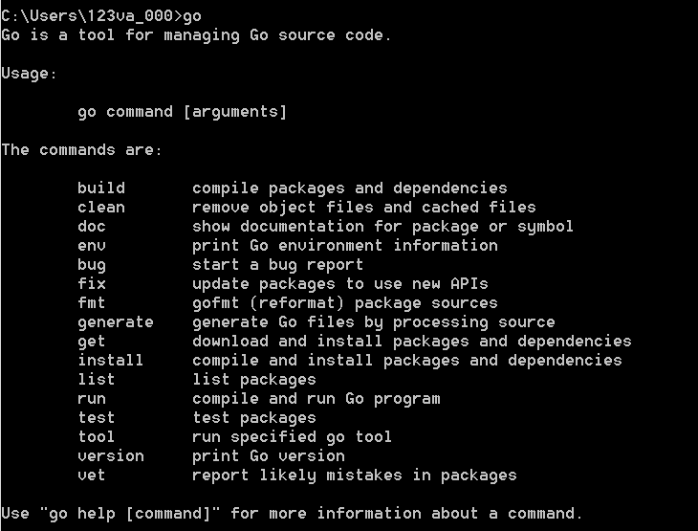

Don’t forget to set your GOPATH variable and make sure that $GOPATH/bin is part of your path.

**-Install Flogo CLI**

go get -u github.com/TIBCOSoftware/flogo-cli/...

once successful installed you should see the flogocli under $GOPATH\bin\bin

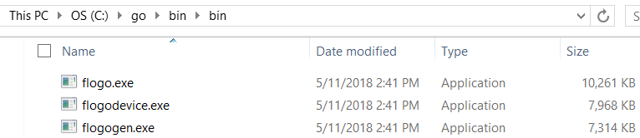

**- Running Flogo Web Ui**

Start your docker insance locally

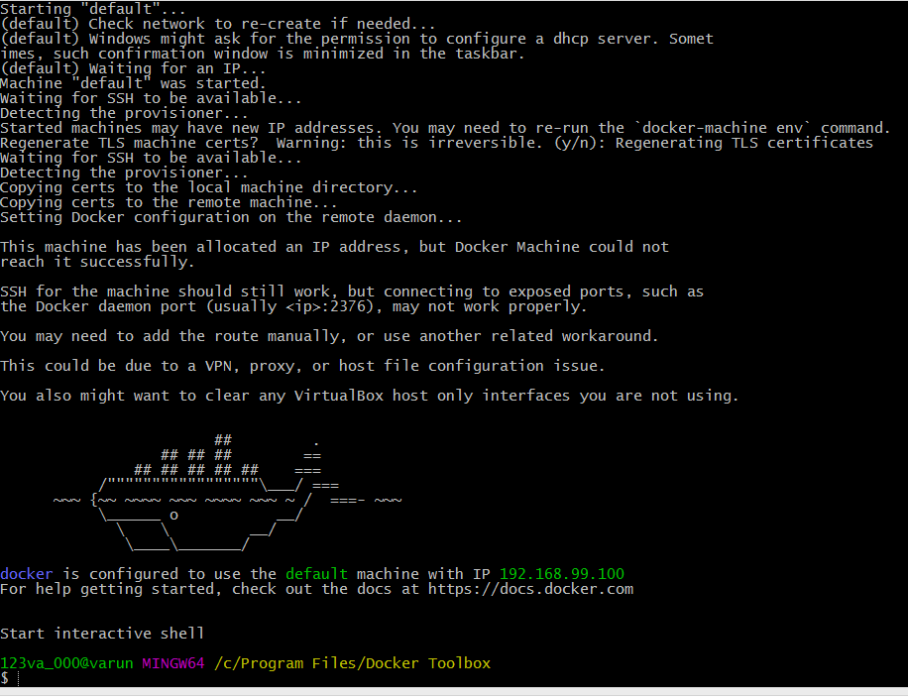

Once the docker is running locally you can start the flogo webUi by issuing the command

**docker run -it -p 3303:3303 flogo/flogo-docker:latest eula-accept**

Will auto download flogo image if no already present and run it.

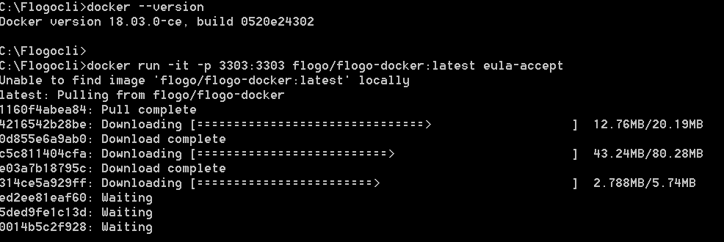

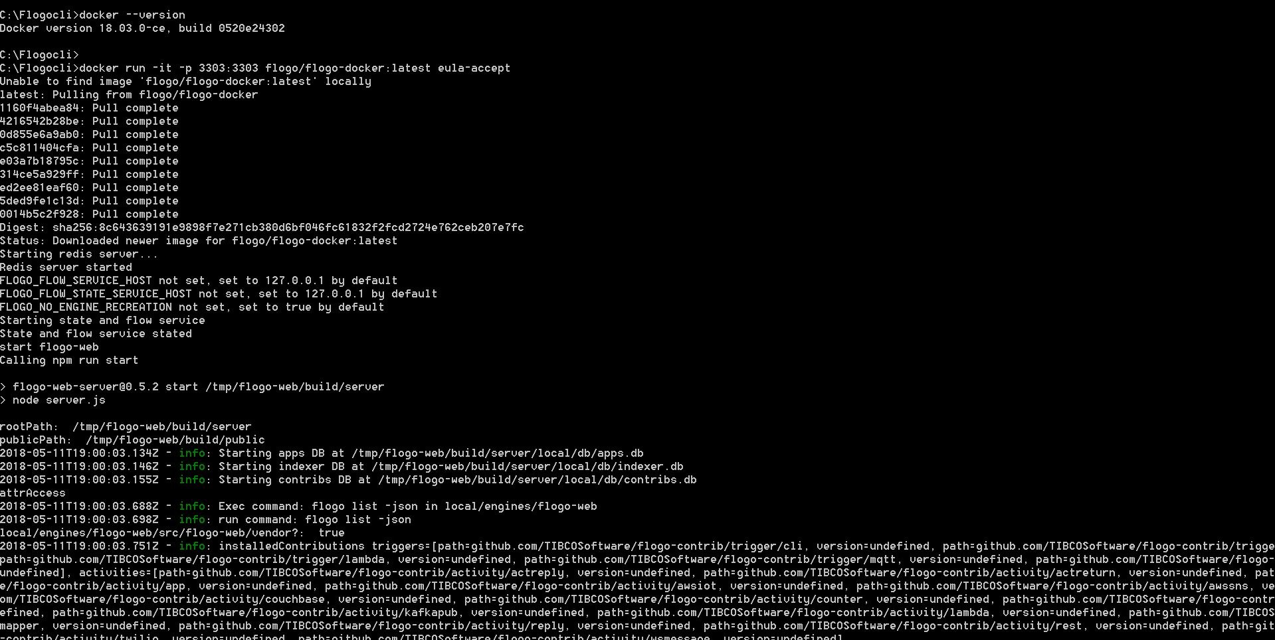

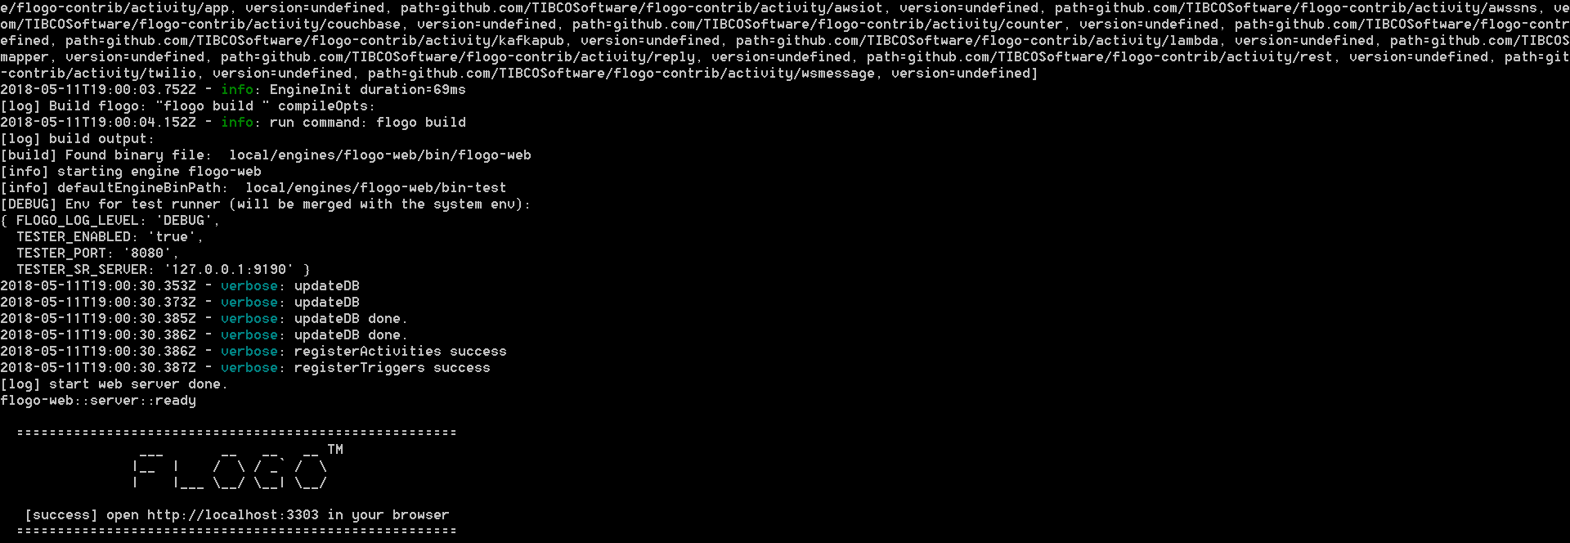

Access the flogo webui using http://localhost:3303 or http://<<docker-ip>>:3303

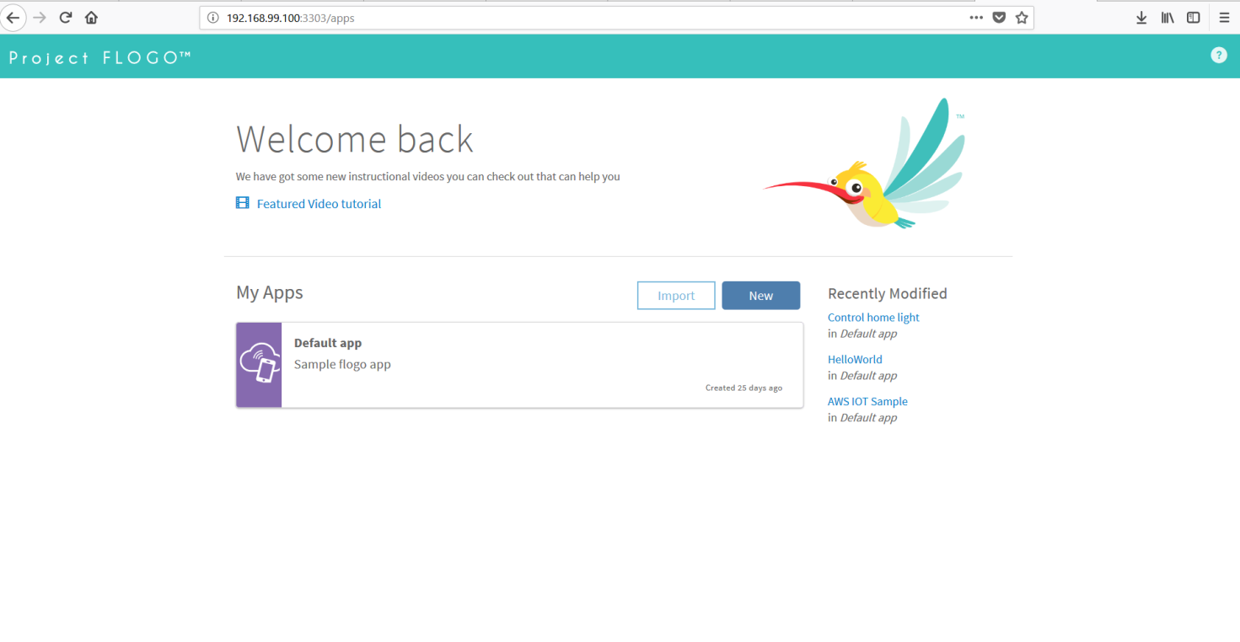

# Building Flogo Microservice

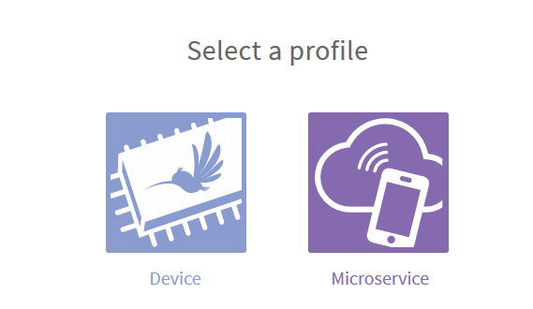

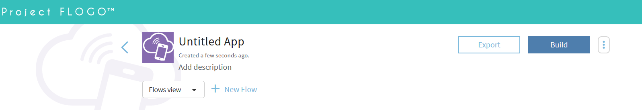

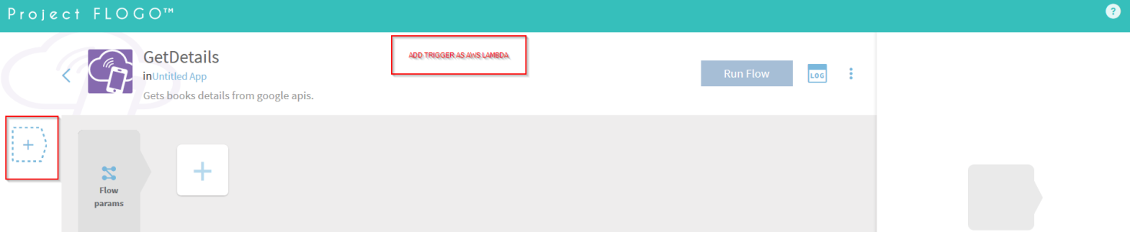

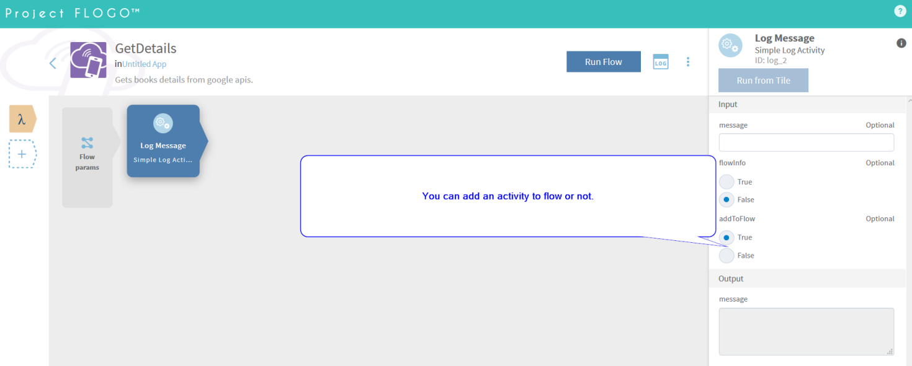

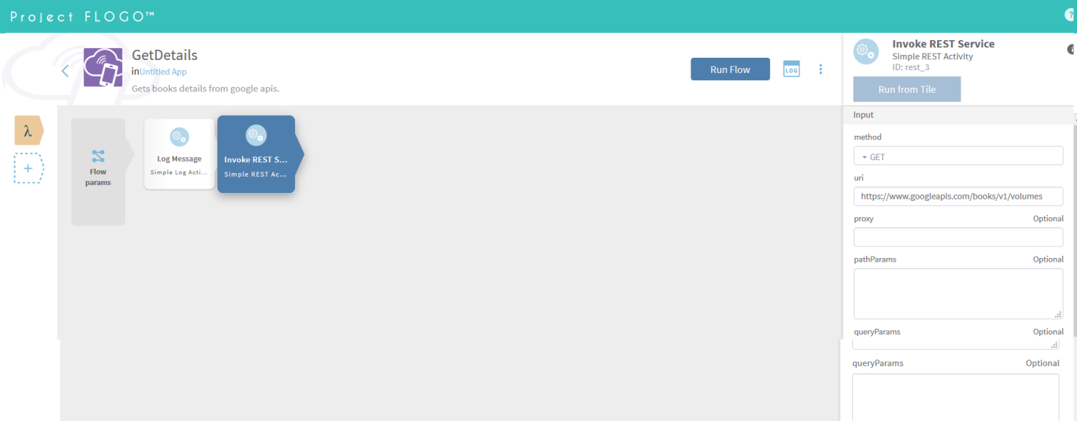

add a simple rest activity. That invokes https://www.googleapis.com/books/v1/volumes

by adding a branch you can do a transistion condition.

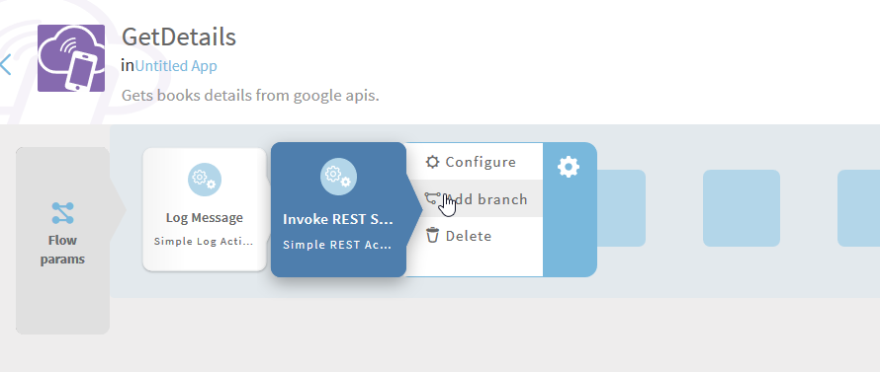

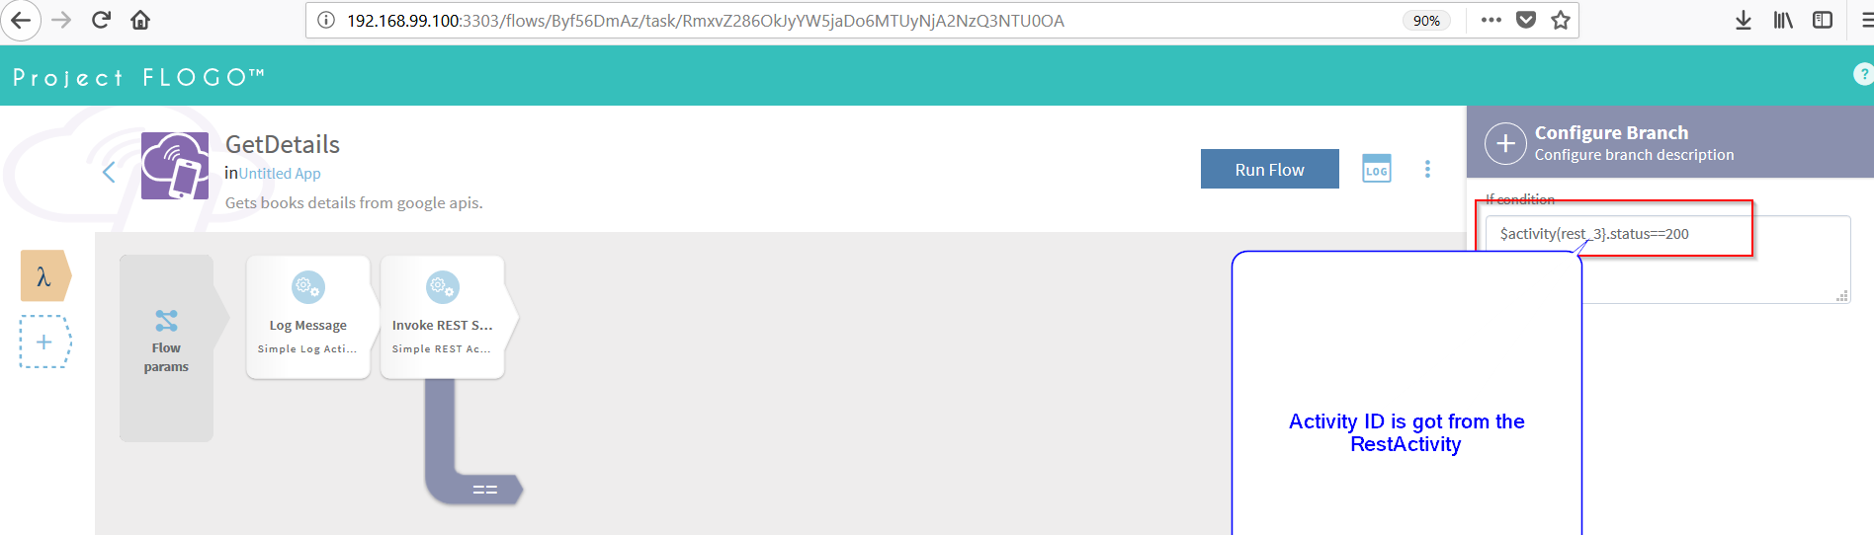

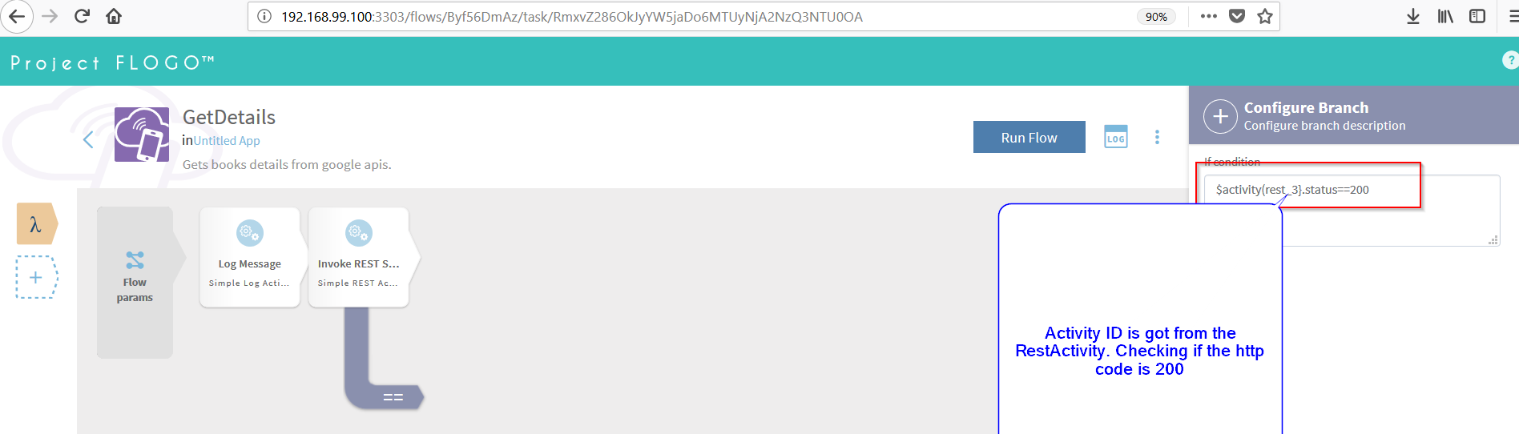

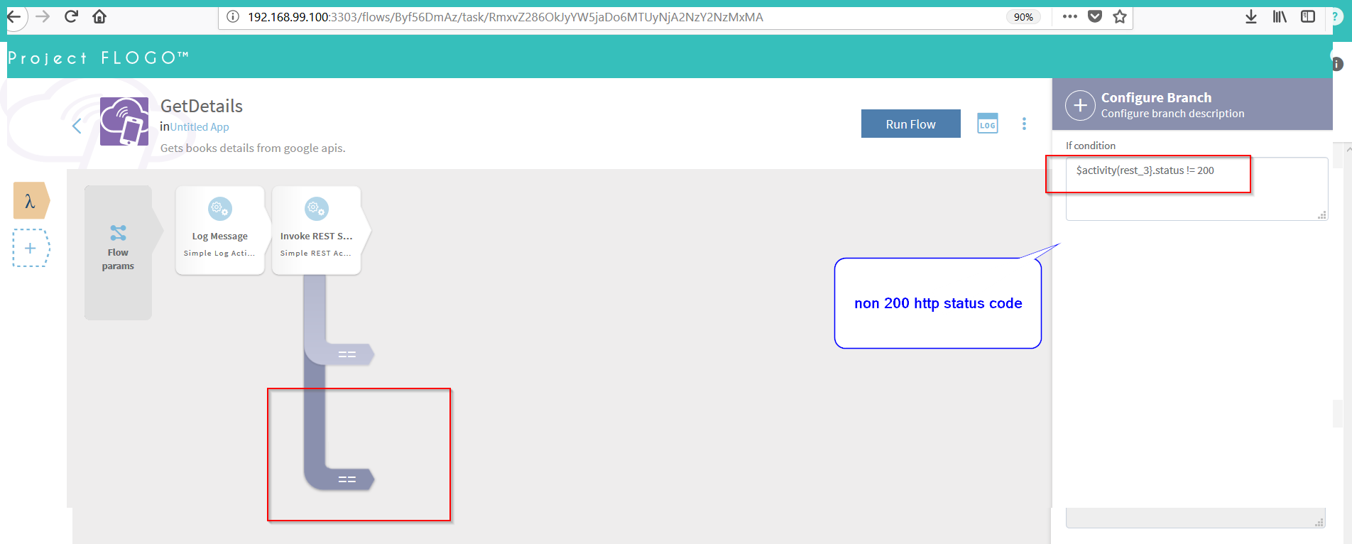

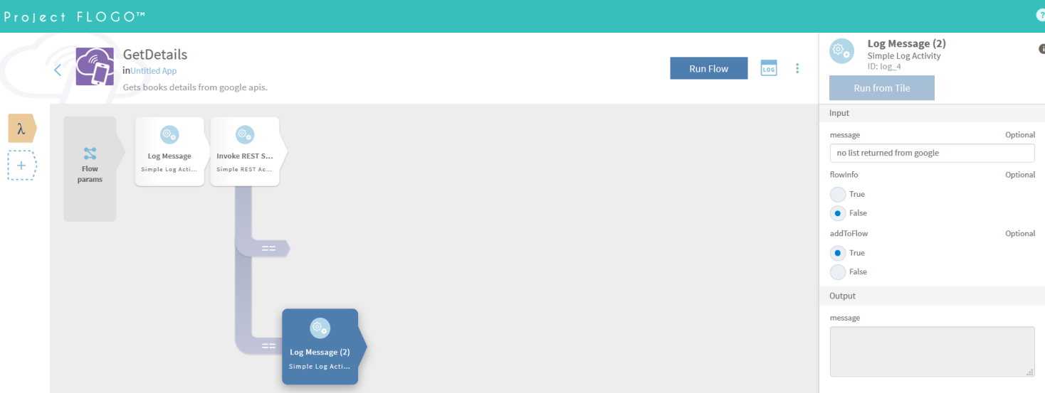

Centrailised tool for managing a cluster of docker containers. It manages and schedules the docker containers across a cluster of machines. It provides a managed cluster management infrastructure.

It also comes along with

* Automatic placement (when running low on resources)
* Recovery (When containers fails while running)
* Load-Balancing (Automatically adds containers behind the scen)
* Push-button deployments
* Cross –instance linking.

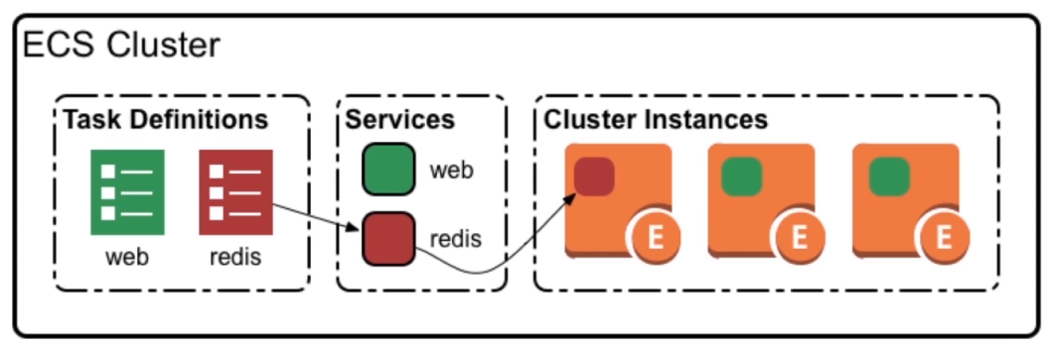

AWS provides prebuilt machine images that will connect to a cluster on launch or you can build own instances and run the ecs agent on those machines.

**ECS TASK DEFINITIONS**

Once the cluster instance is steup running the containers on those mahines is achieved by using TaskDefinitions in ECS. These definitons can be scheduled as a service in the cluster.

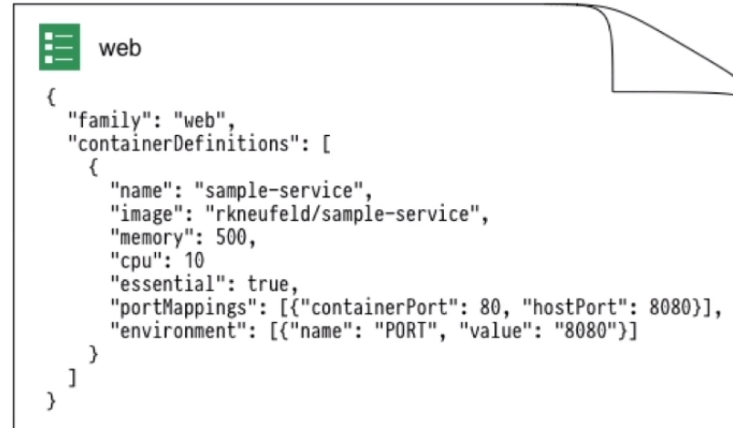

Once a task is created, it needs to be scheduled to run in a cluster. ECS provides three options for running a task.

* Run once (Run until completion. Launches a containers lets it run until it exits on its own.)
* Run as service (Create a service inside of a cluster specify how many conatainers instamces you would like to run, ECS will take care of running those containers for you persistently.)
* Custom (Built on top of ECS/Mezos scheduler driver, for fine grain control on when to run a container)

# Tibco Flogo Enterprise Setup

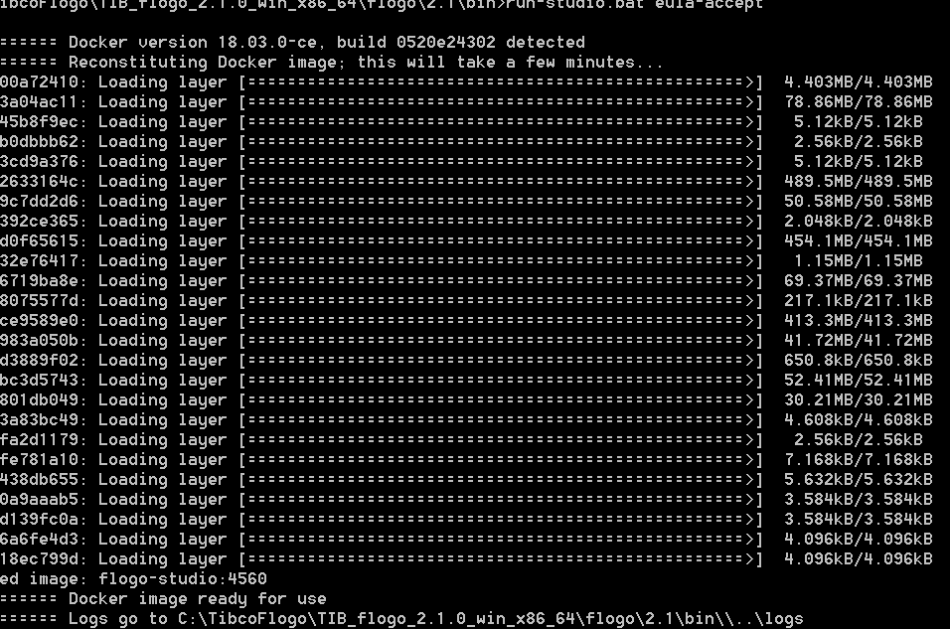

# Installing Flogo On AWS ECS

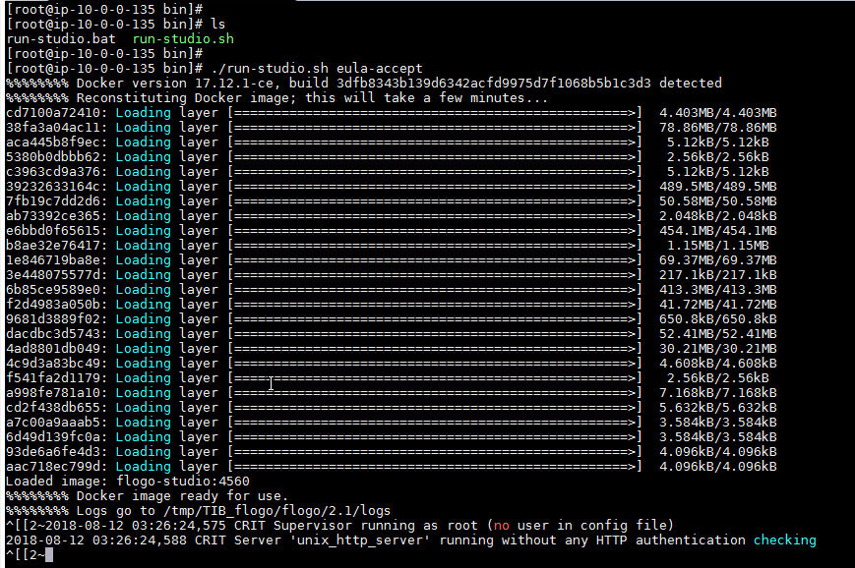

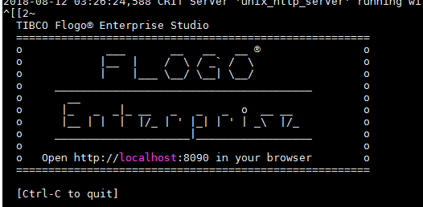

change the firewall rules for the ecs

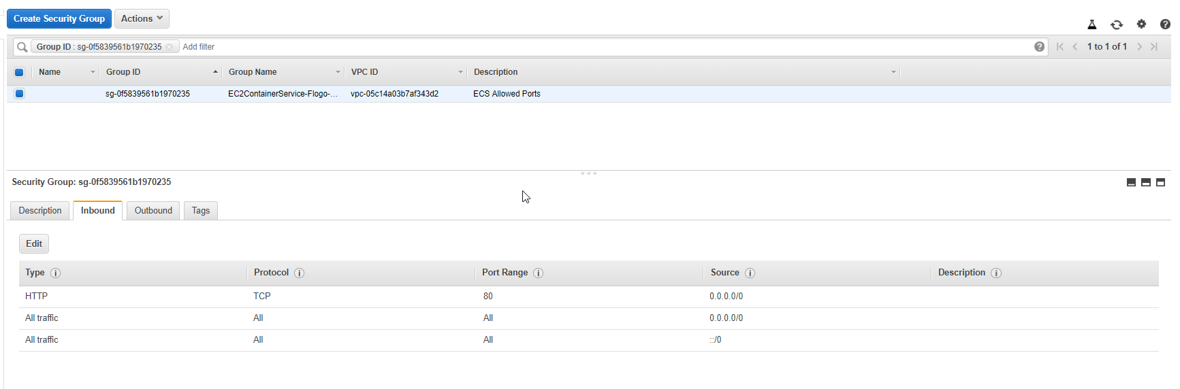

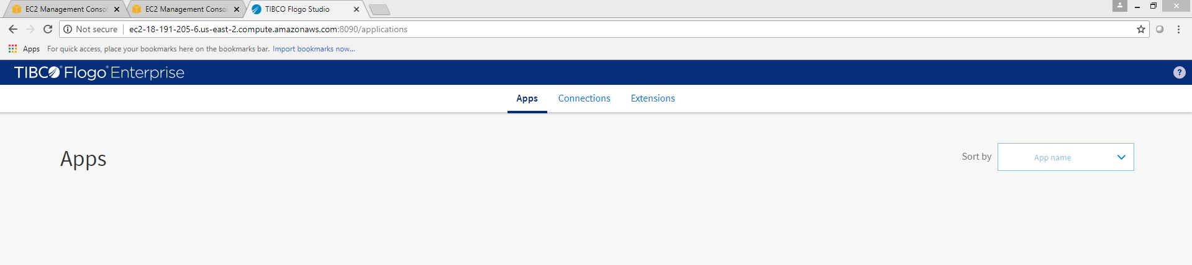

# Development

Concepts

**Tiles**

There are two categories of tiles used in a flow - Triggers and Activities. A flow starts with a trigger which is then followed by one or more activities. Each flow can have only one trigger.

**Flow**

Every TIBCO Flogo App must contain at least one flow. An app can consist of multiple flows. A flow is a process that contains the business logic of the app. A flow is activated by a trigger. You have the

option to create a flow with or without a trigger. A flow without a trigger is a blank flow. You can add

one or more triggers to a blank flow at any time after the flow creation. Each flow can contain one or

more activities.

Trigger

Triggers are used to activate a flow. A trigger can also be activated by an external system, such as

Salesforce.com, in which case the TIBCO Flogo App listens to changes happening in that external

system.

Activity

Activities perform specific tasks within the flow. A flow typically contains multiple activities

# Creating Flogo App

Configure the http receiver

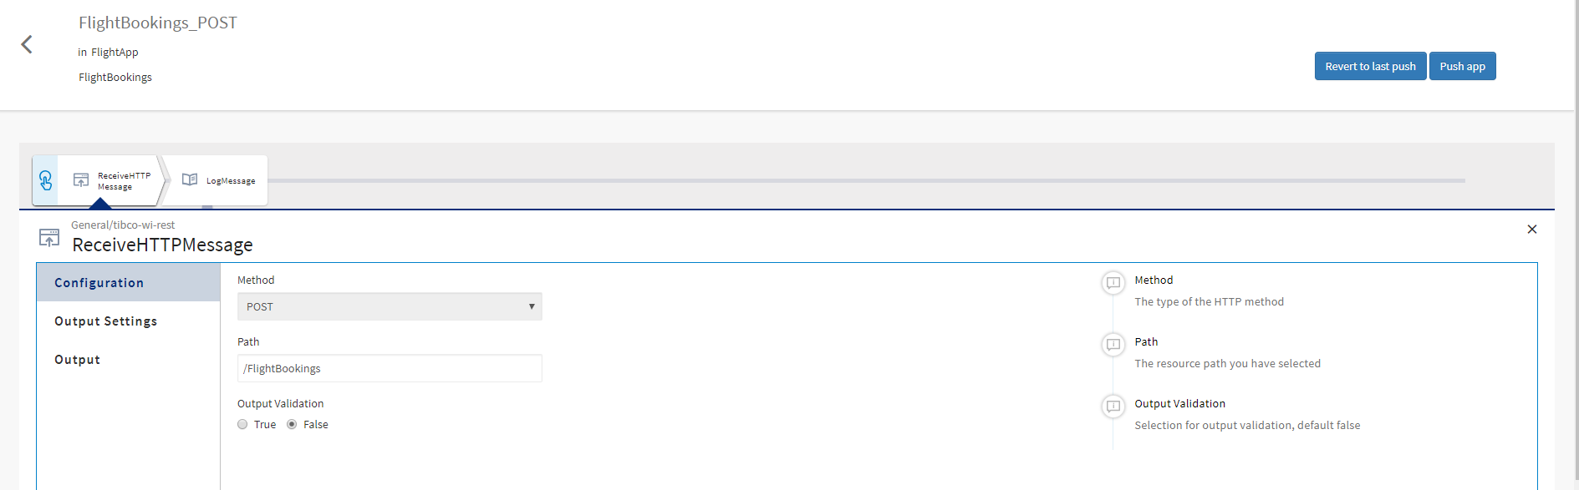

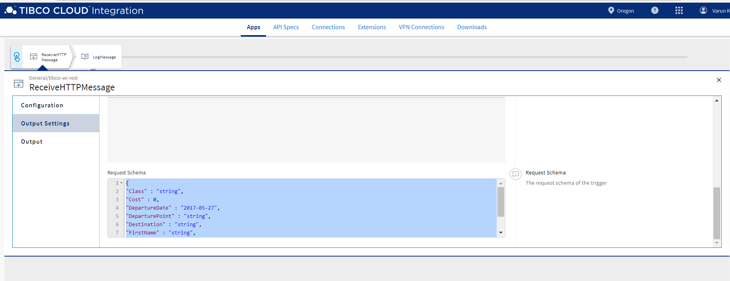

Request Schema

{

"Class" : "string",

"Cost" : 0,

"DepartureDate" : "2017-05-27",

"DeparturePoint" : "string",

"Destination" : "string",

"FirstName" : "string",

"Id" : 0,

"LastName" : "string"

}

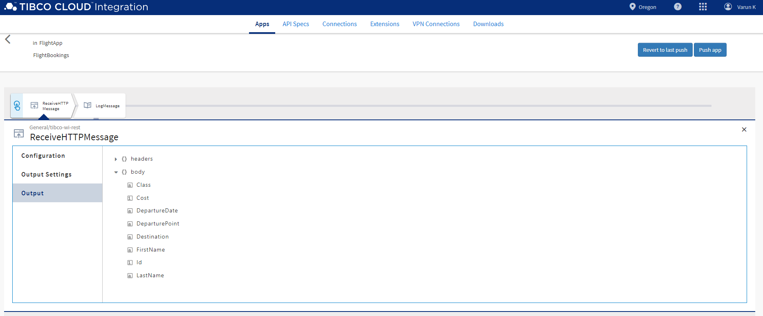

Configure the logs activity.

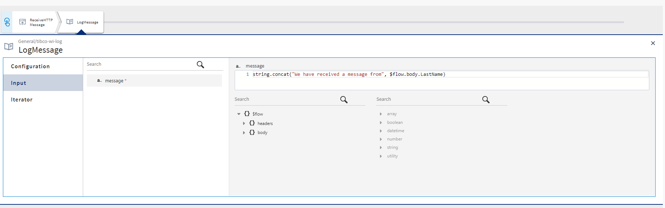

Add a transistion to let any user buy a ticket

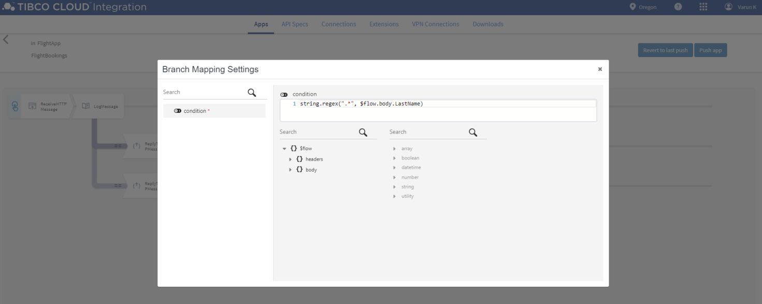

Adding http receiver to reply back confirming the ticket is booked.

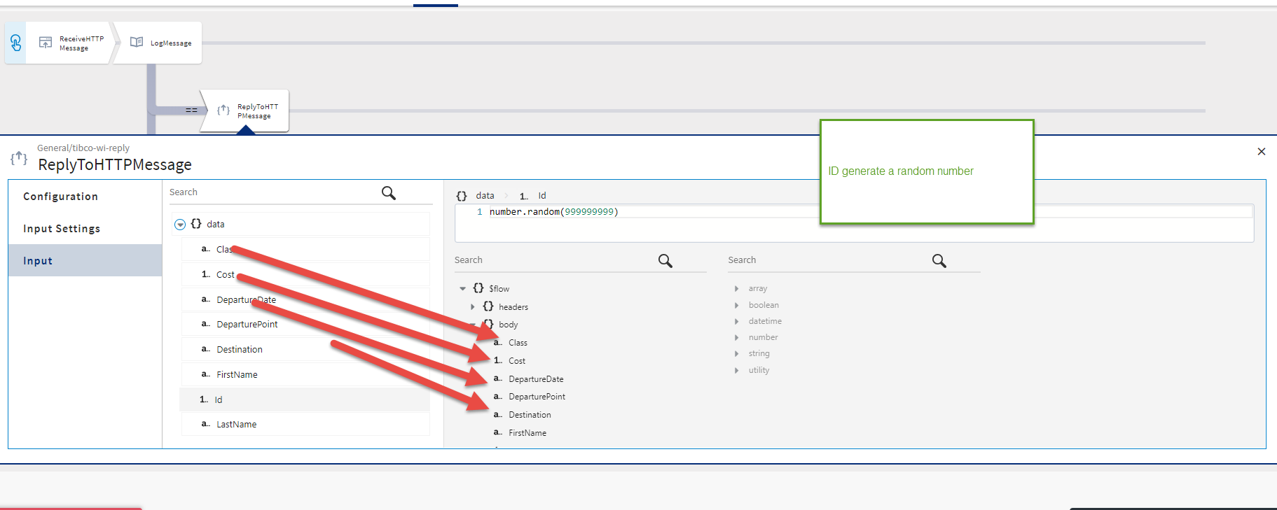

Condition 2 will be to check the user’s last name is equal to Jones and upgrade to business class

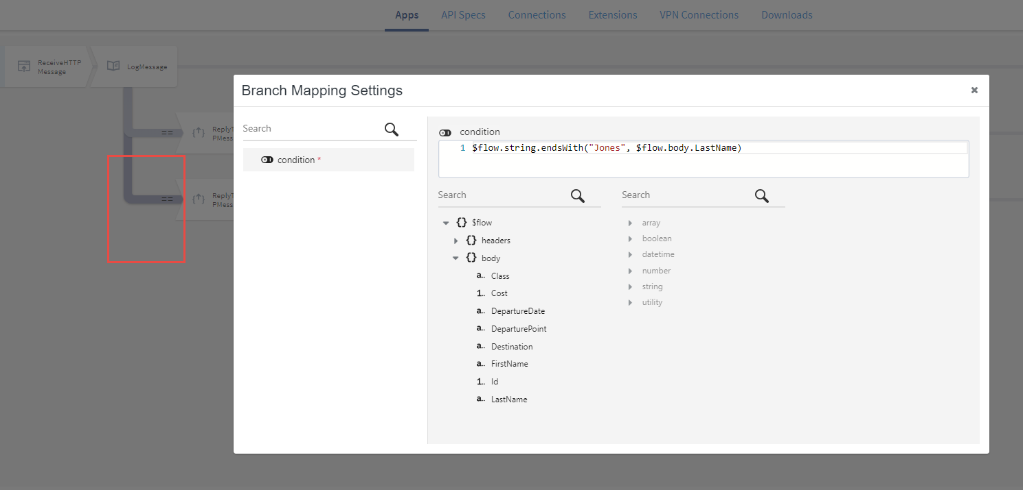

Once the person’s last name has matched Jones confirm the ticket in business class.

{

"Class" : "string",

"Cost" : 0,

"DepartureDate" : "2017-05-27",

"DeparturePoint" : "string",

"Destination" : "string",

"FirstName" : "string",

"Id" : 0,

"LastName" : "string"

}

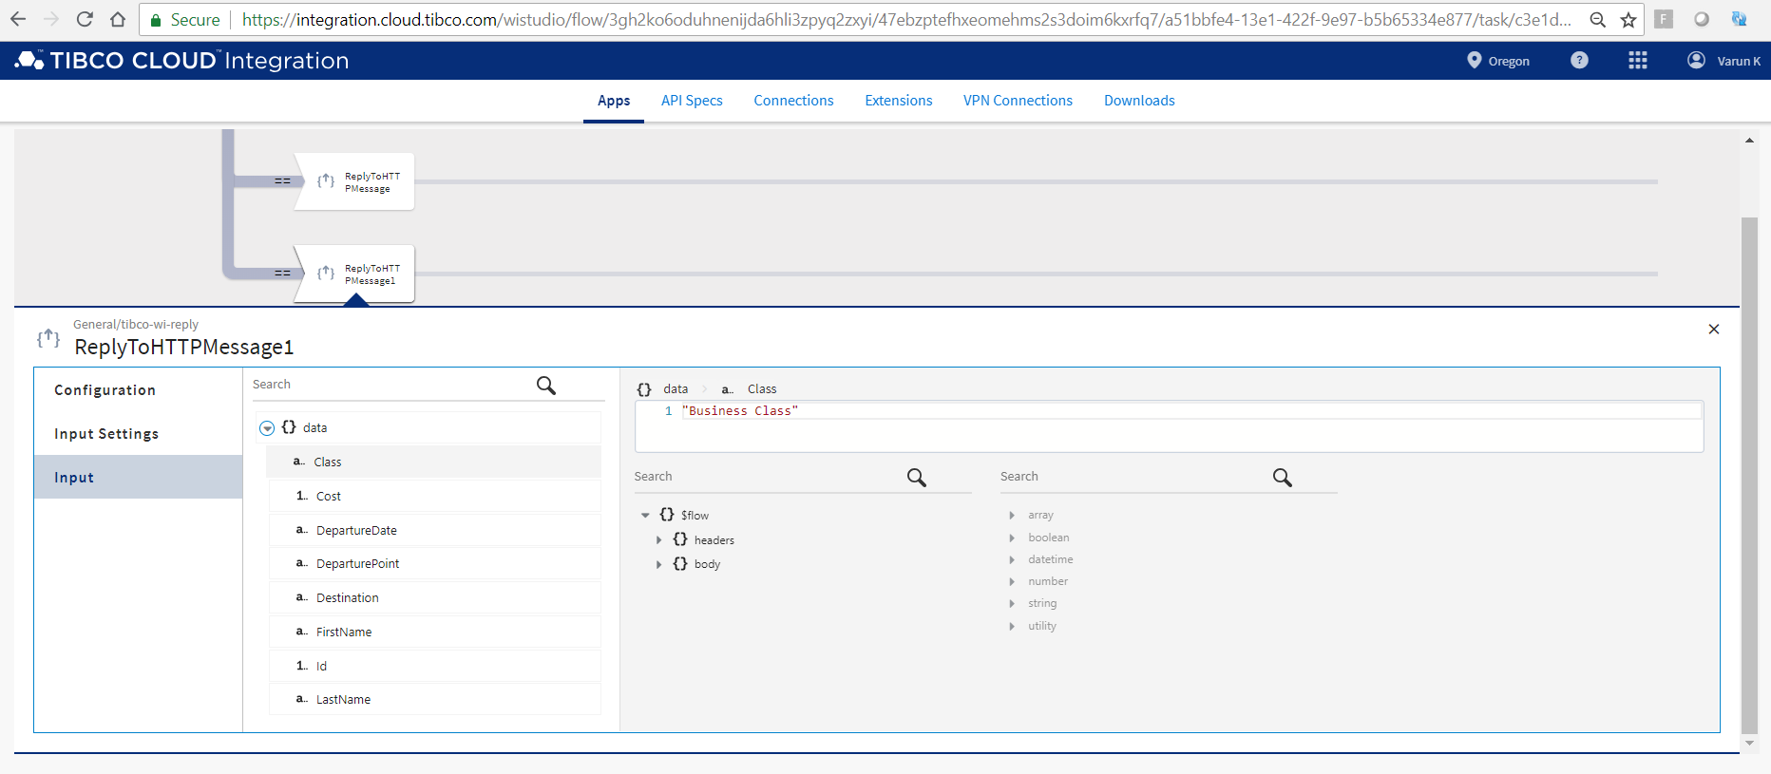

Deploy the app.

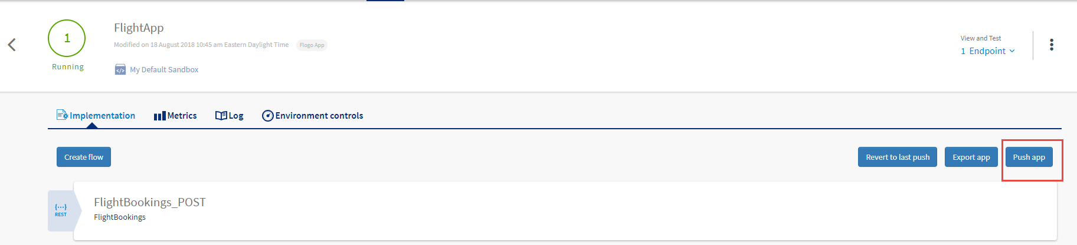

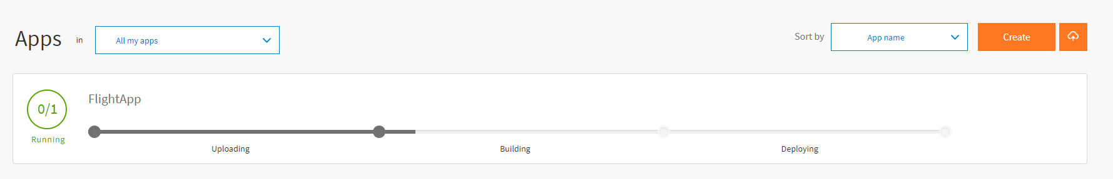

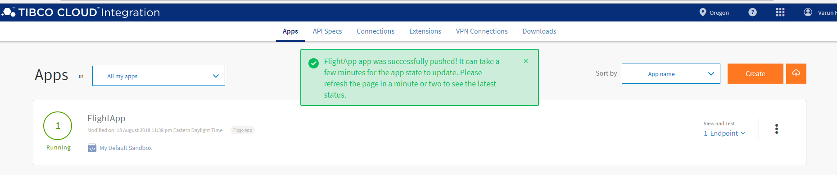

Test the API

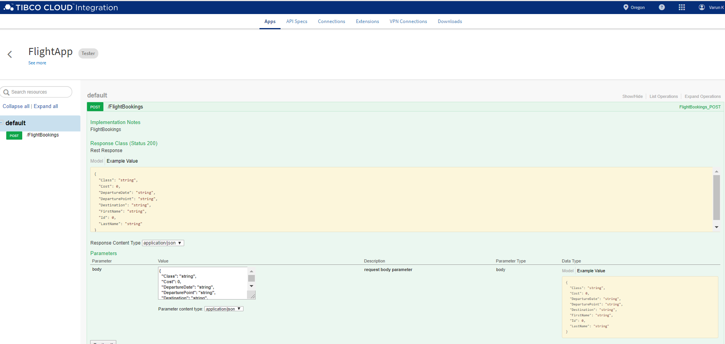

{

"Class": "string",

"Cost": 0,

"DepartureDate": "string",

"DeparturePoint": "string",

"Destination": "string",

"FirstName": "Varun",

"Id": 0,

"LastName": "Karuna"

}

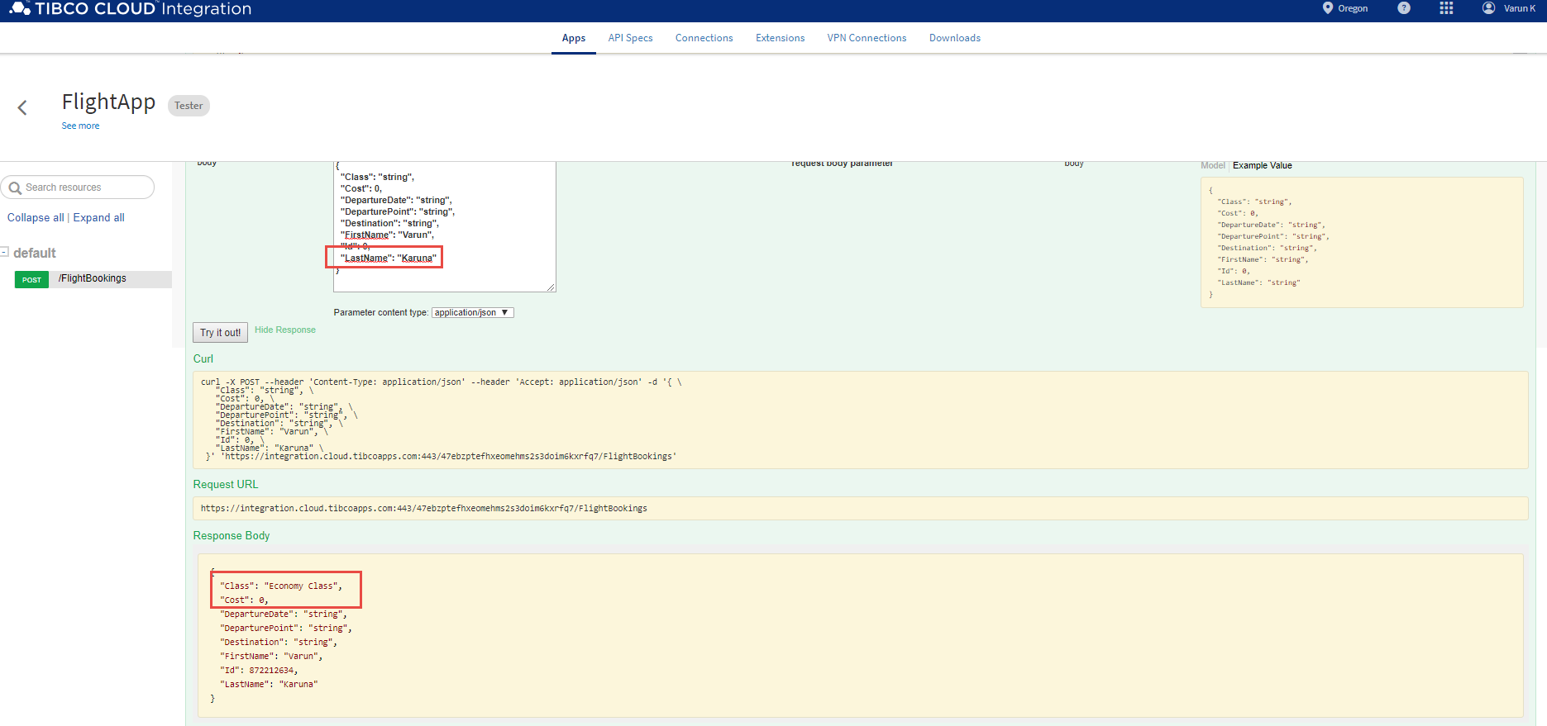

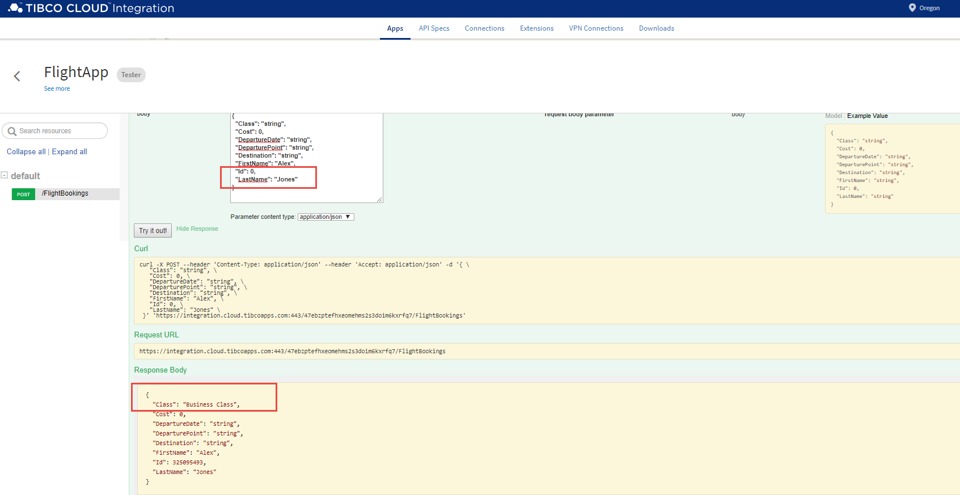

# Setting up AWS connection

Need to setup an AWS connection in order to be able to deploy flogo apps to AWS lambda. Configure the AWS connection with the user that wll be used to deploy the lambdas with.

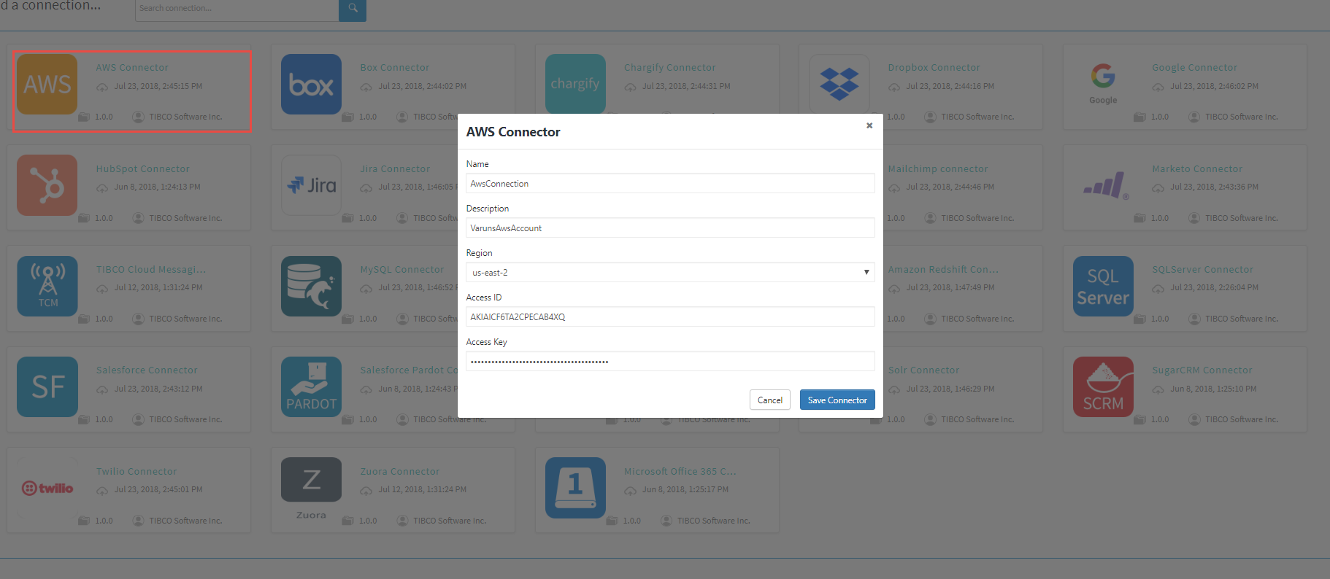



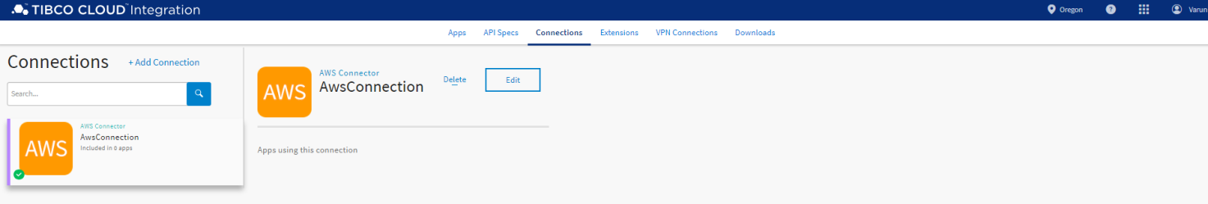

# Creating Flows With Triggers

# Publishing logs to Splunk From Flogo

A blank flow can be created just like a subprocess in bw/bwce where this blank flow can be used as a framework to be called multiple times. In the below example I am not using a blank flow but direct avtivity.

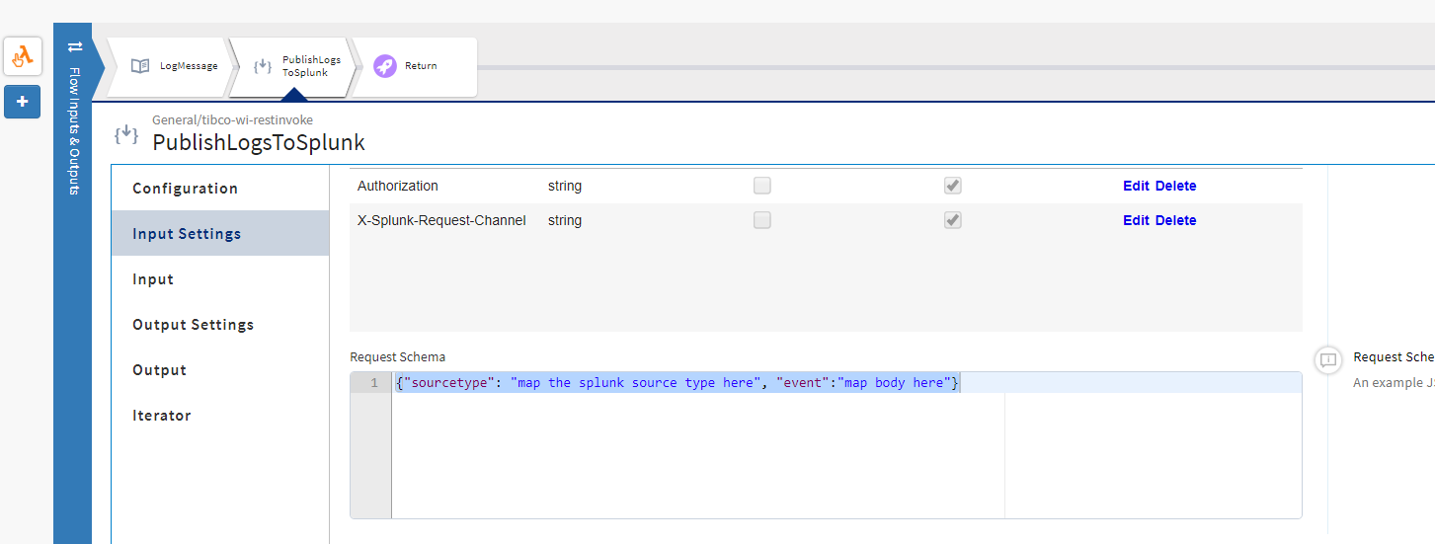

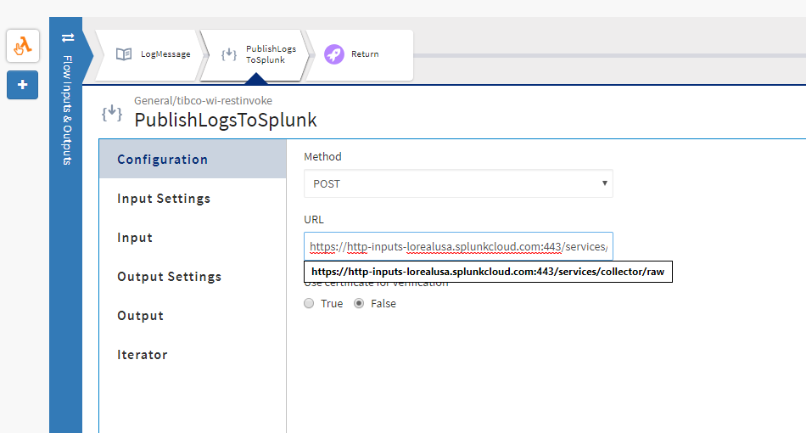

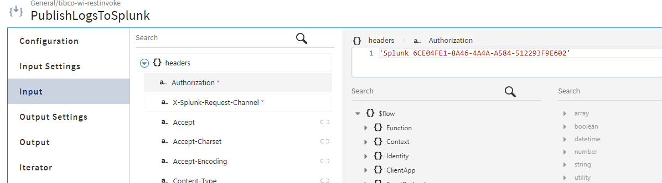

add the response schema that splunk will reply with once the logs are written successfuly to splunk.

configure the authorization with the splunk HEC token.

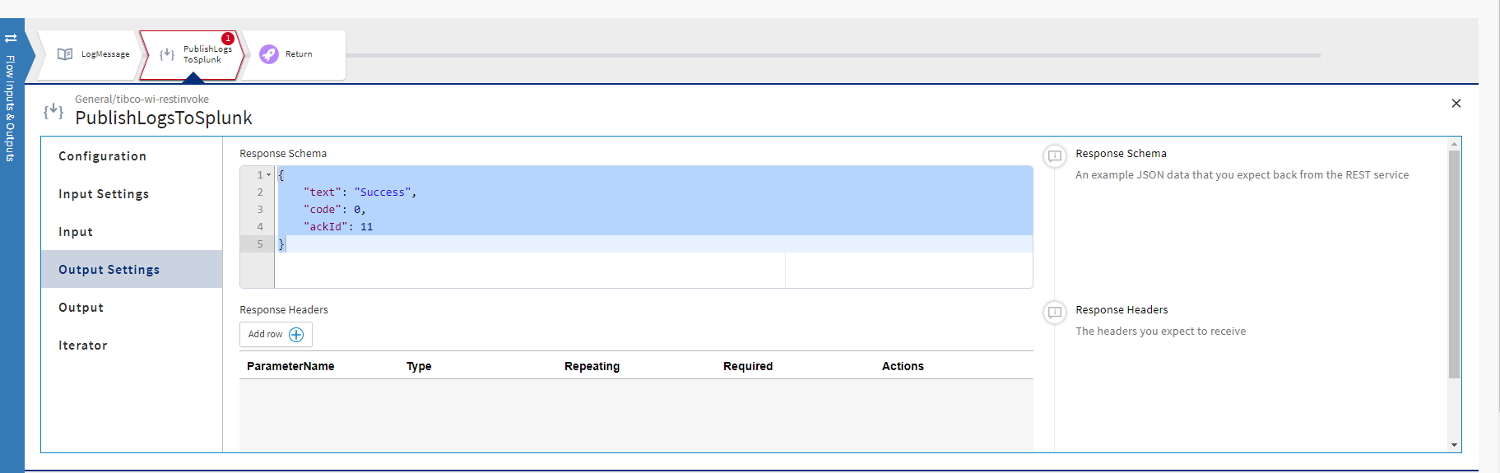

map the body

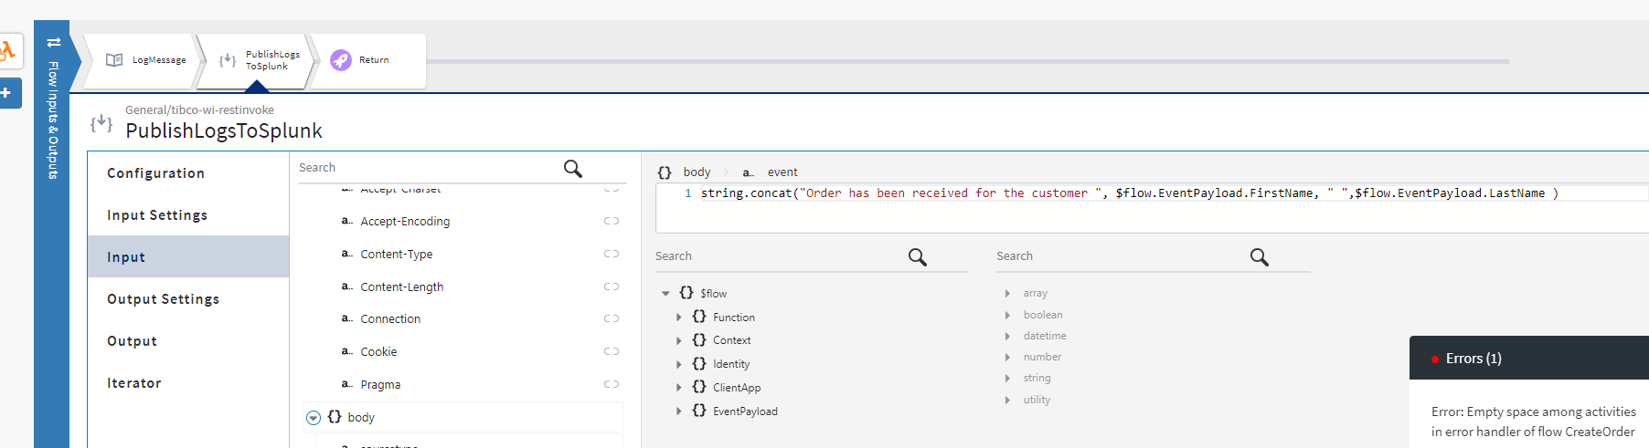

We will see the logs getting written to splunk in below sections.

# AWS Lambda Invocation (ORDERS API) Bulding Basic Flow

The idea is to build an order flow. That will accept order information and persist the order information in AWS REDSHIFT DATA STORE

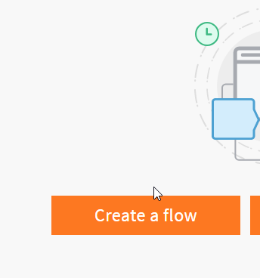

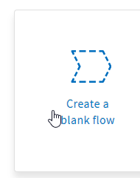

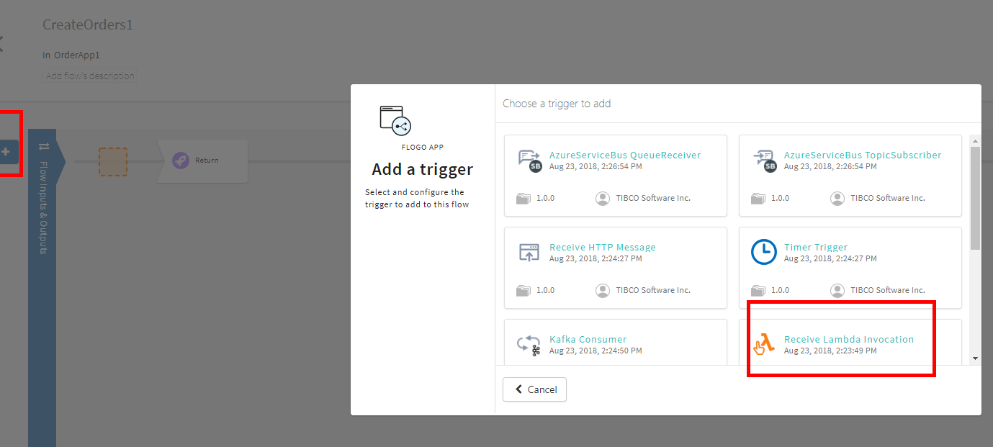

add the lambda input over here

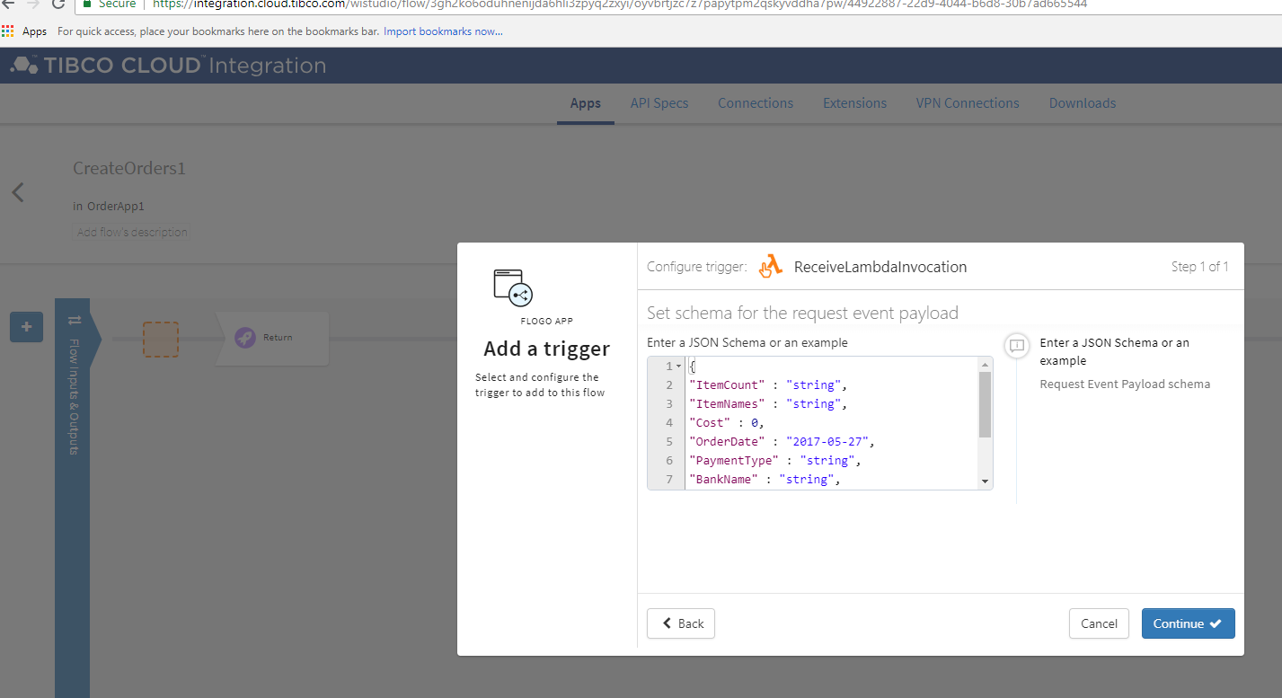

Select the aws connection and the role name(must match aws)

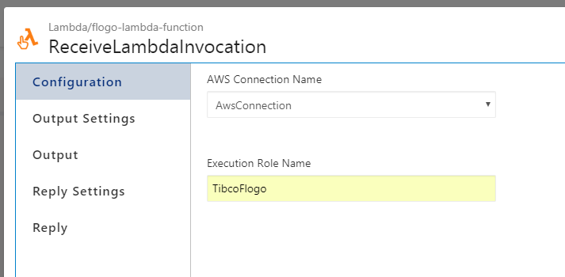

add output reply for the aws Lambda

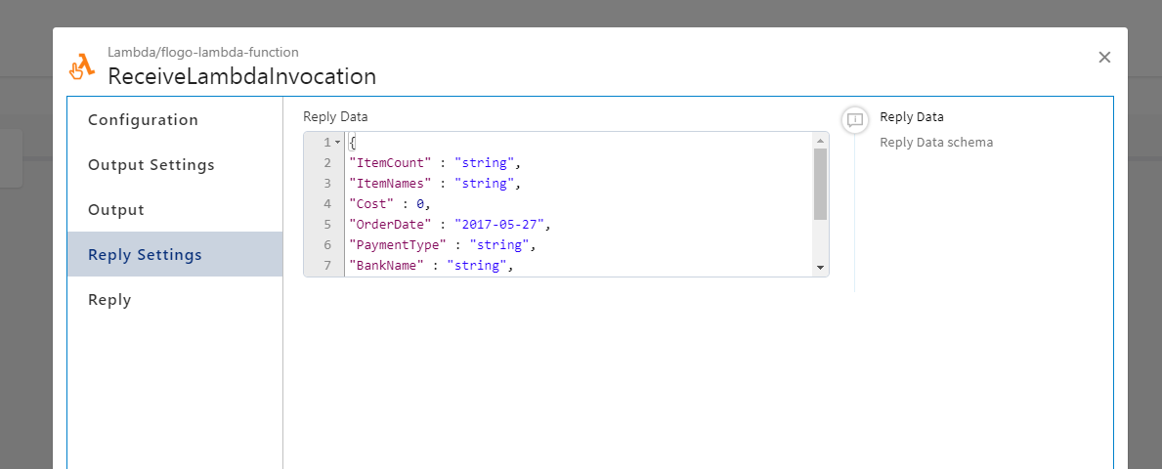

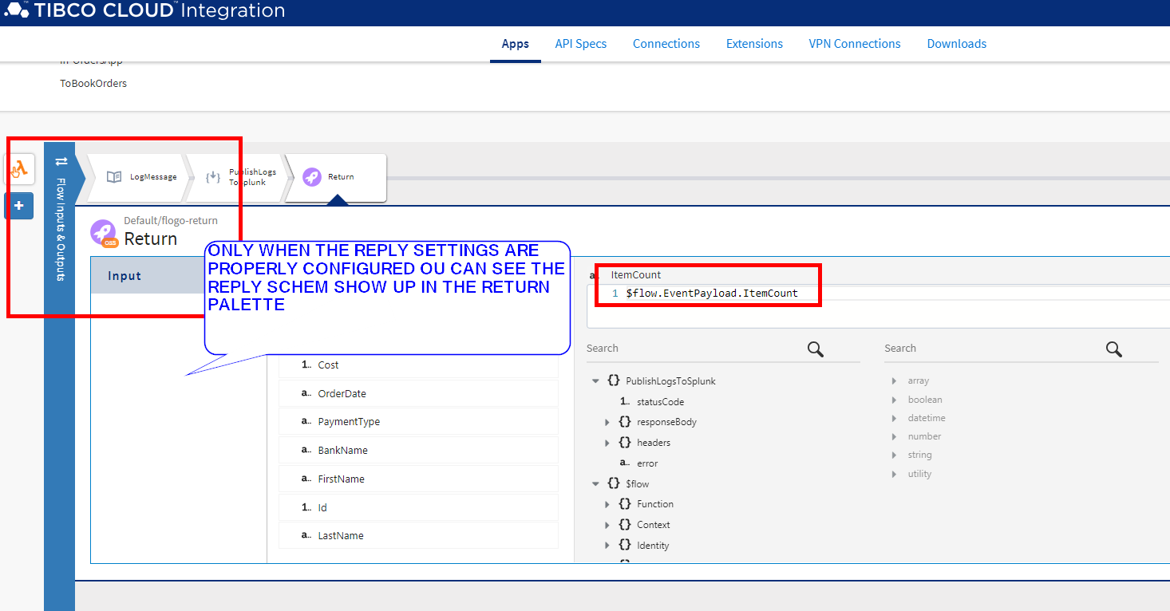

add a log messge to splunk with the following info.

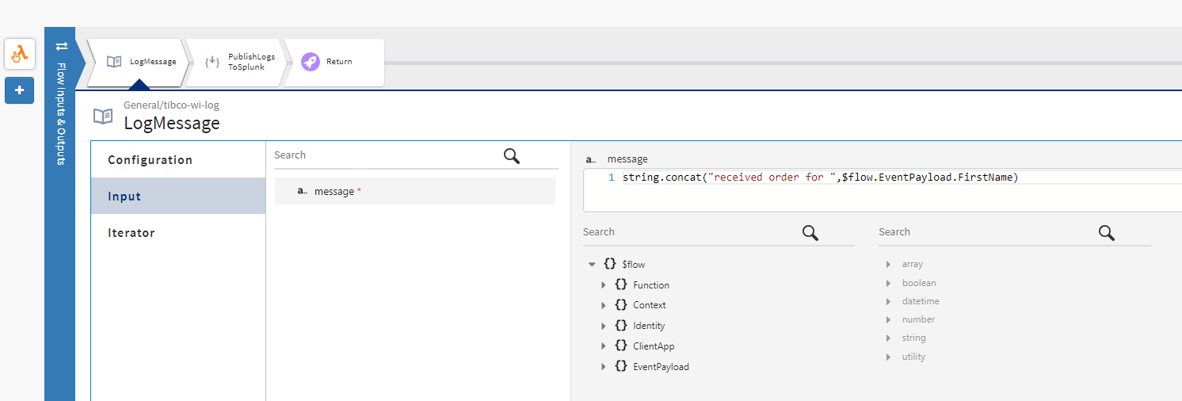

map the return as expected.

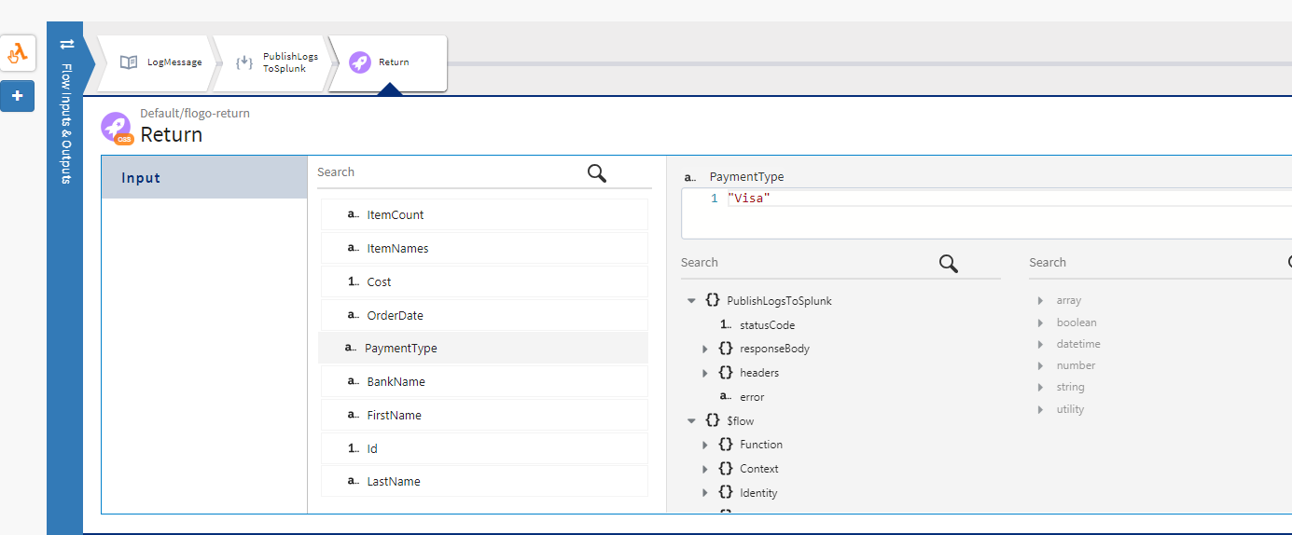

We will test thid basic flow before we add the persistence to AWS RedShift later

Push the app to Lambda



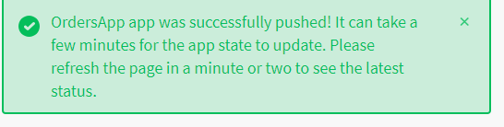

check the logs

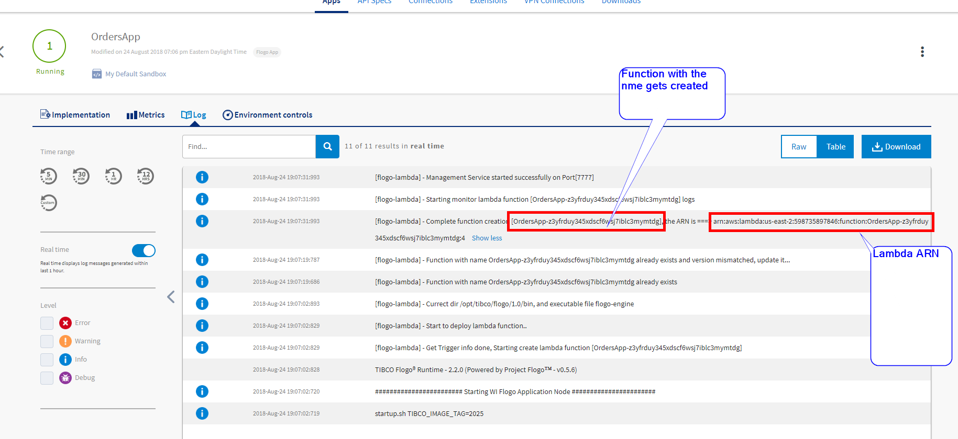

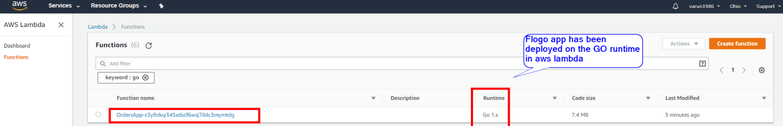

Lets do some basic testing for now. We will create the AWS apigateway wrappers later on.

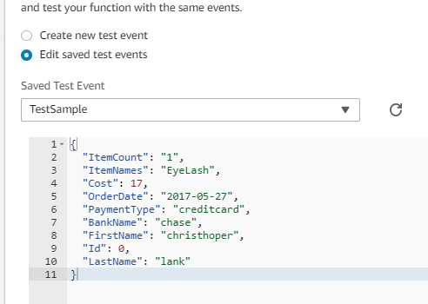

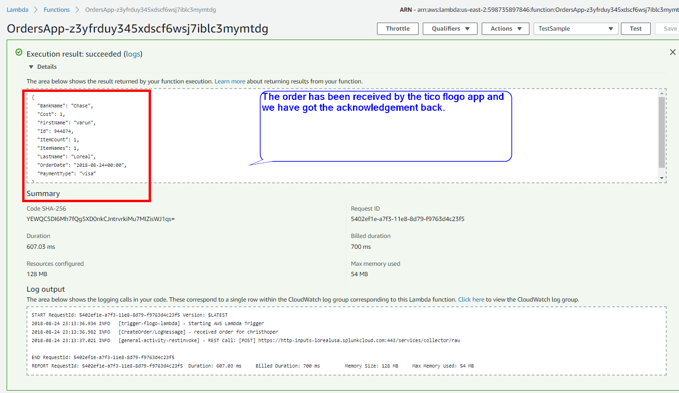

Checking if the logs are published to splunk.

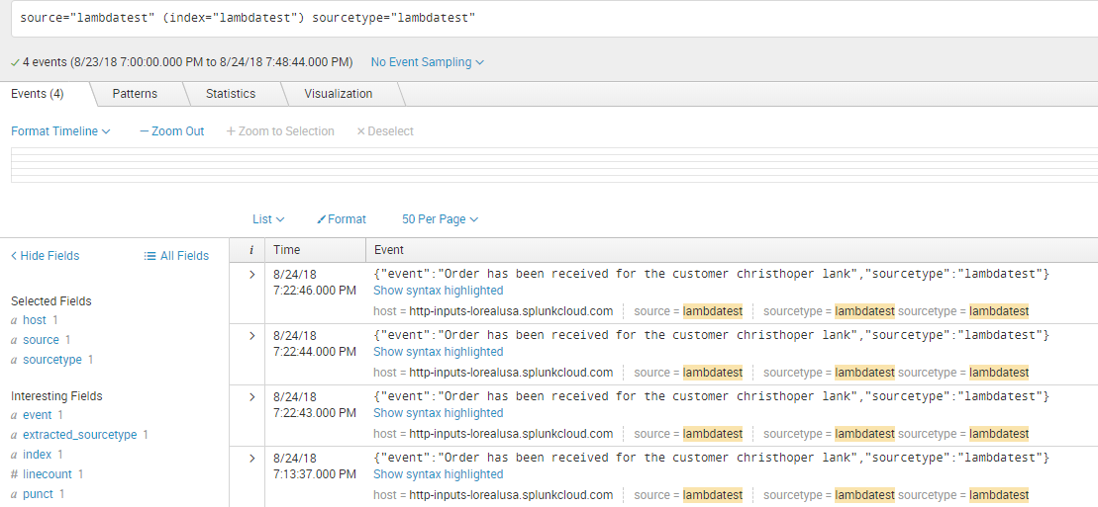

# Configuring AWS Redshift

Before the Redshift cluster is created. Complete the following two steps.

1) creae a subnet/security group.

2) create a IAM role

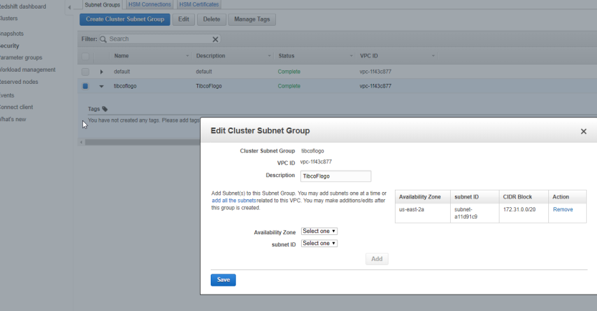

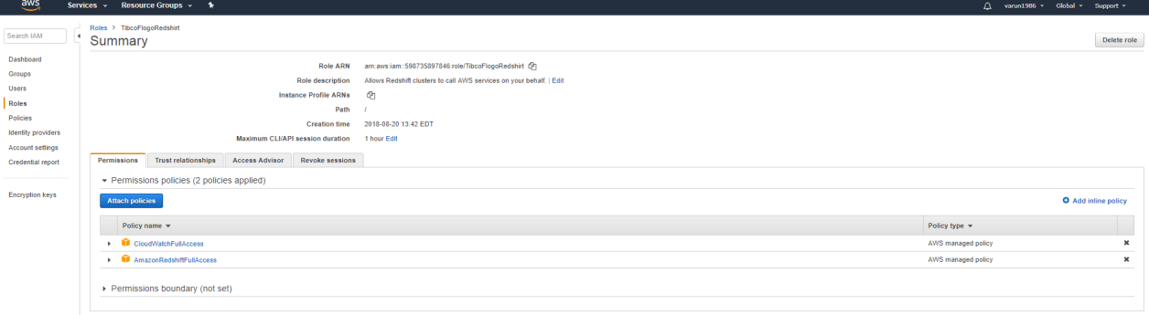

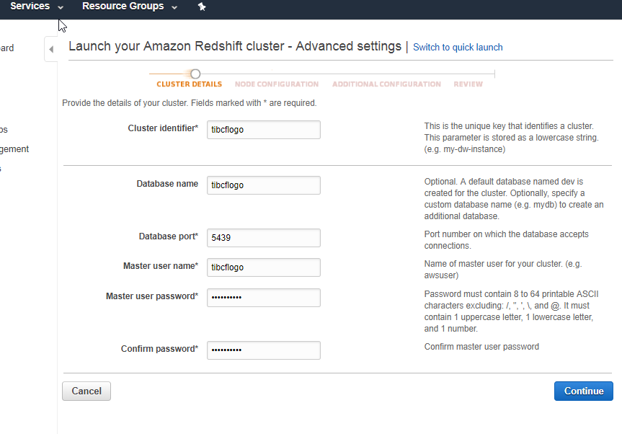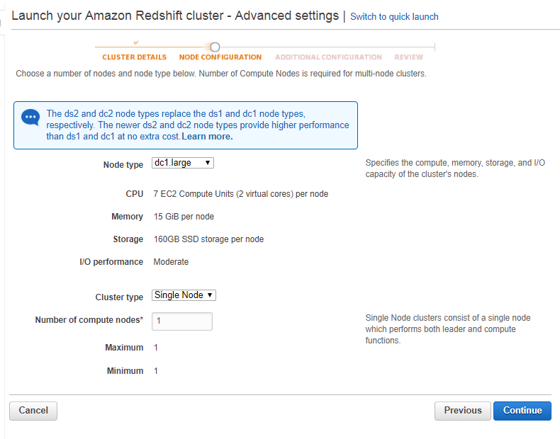

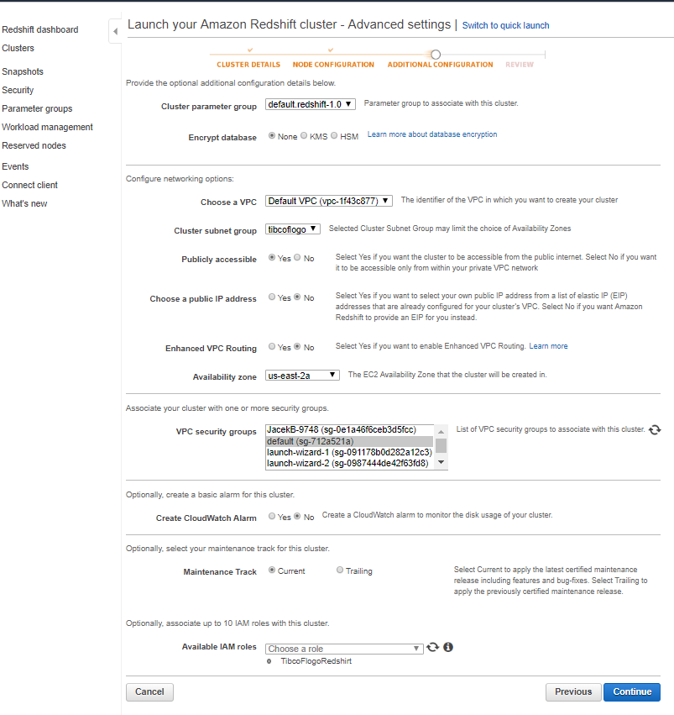 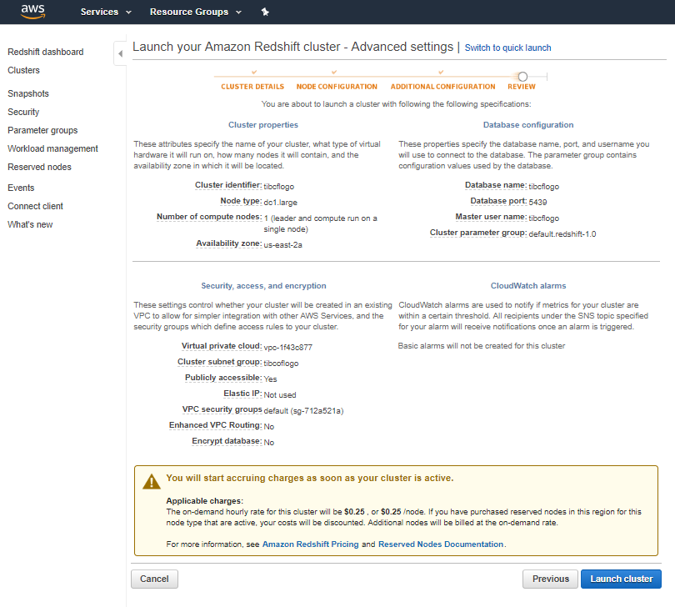

Once the redshift cluster is ready.

Once the cluster is r.s cluster is ready.

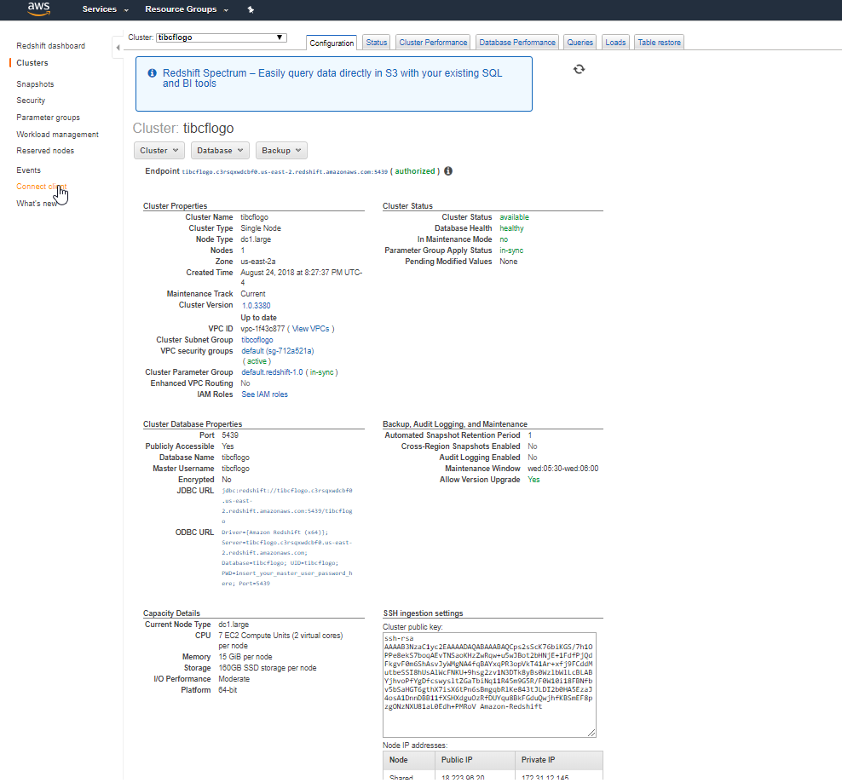

Connnect to redshift using sqlworkbenchj

C:\tibcobw6\tibcojre64\1.8.0\bin>java.exe -jar C:\mysqlworkbench\Workbench-Build124\sqlworkbench.jar

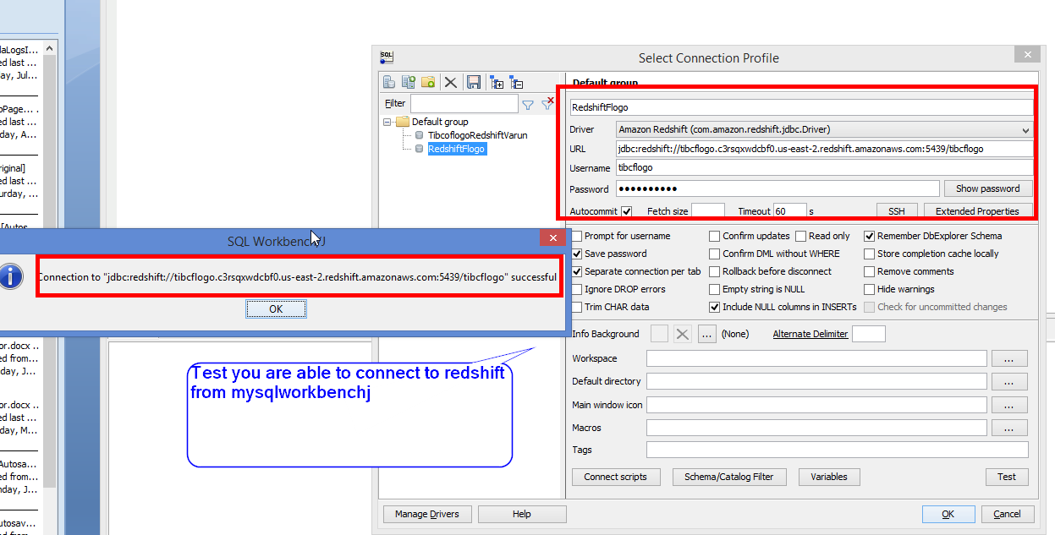

create a simple table

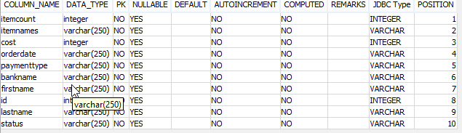 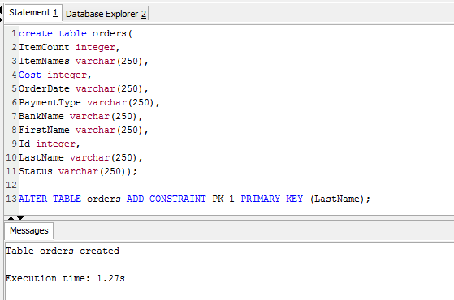

# Redshift Connection In Flogo

Connect to reshift from flog. Should see green check.

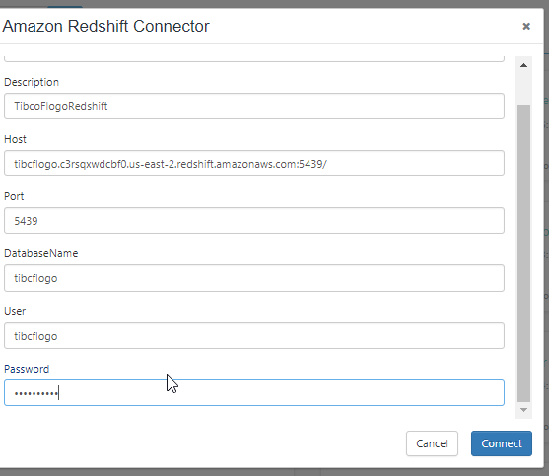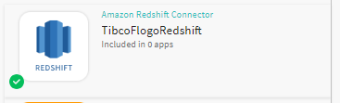

# Custome Extension For DynamoDB

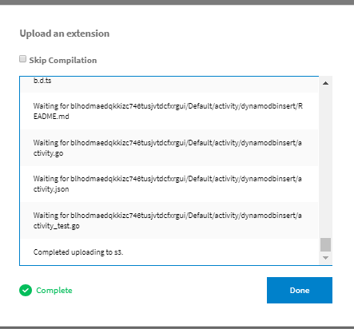

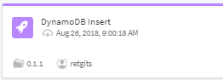

# DynamoDB setup

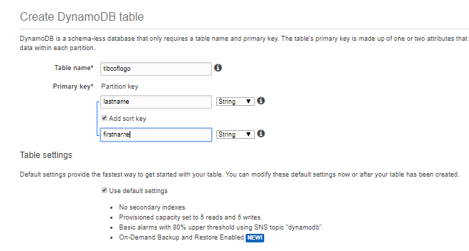

create a DynamoDB table

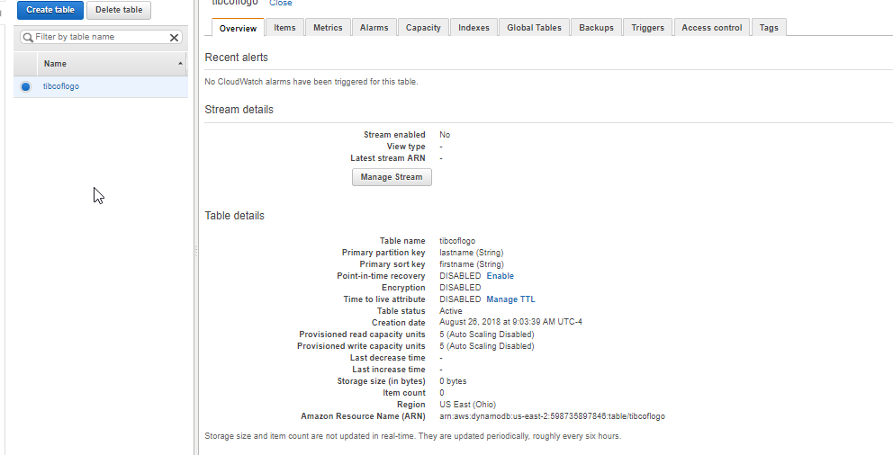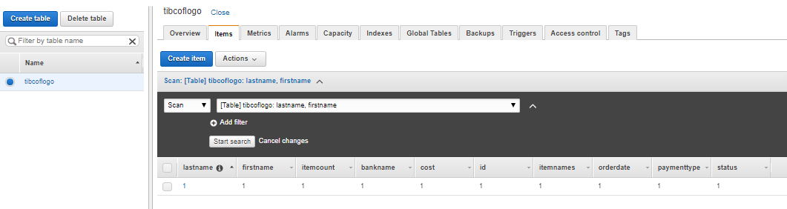

create an IAM role that will let your lambda function to be able to insert/update records into dynaodb table.

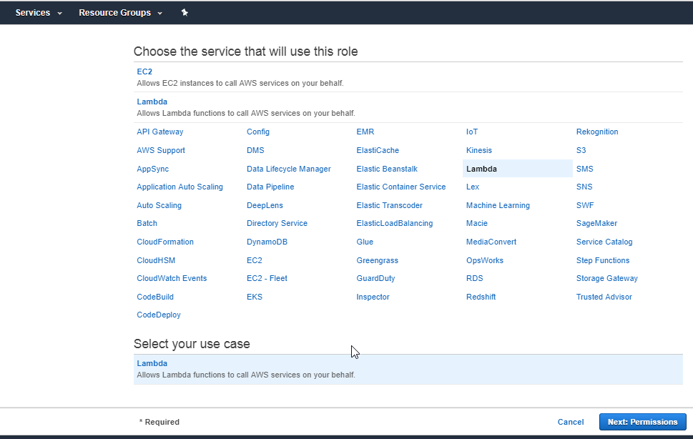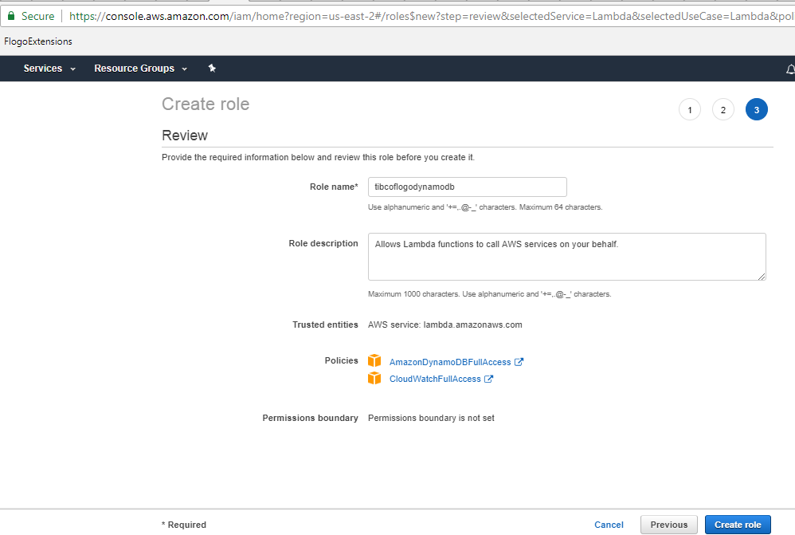

# Persisting Records To DynamoDB From Flogo

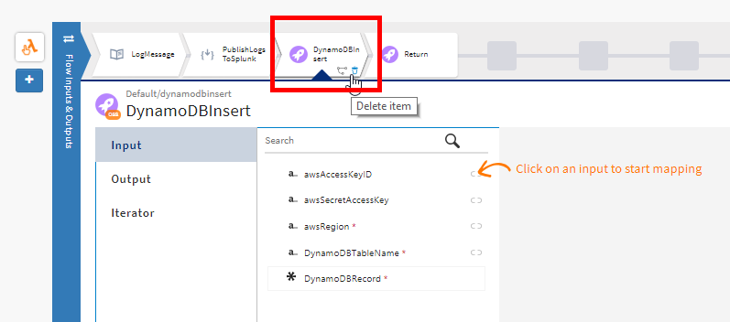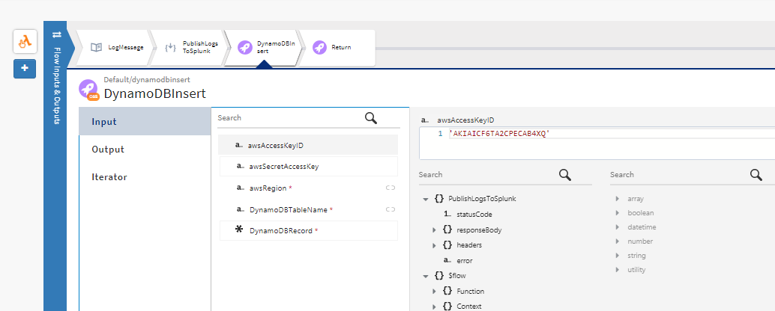

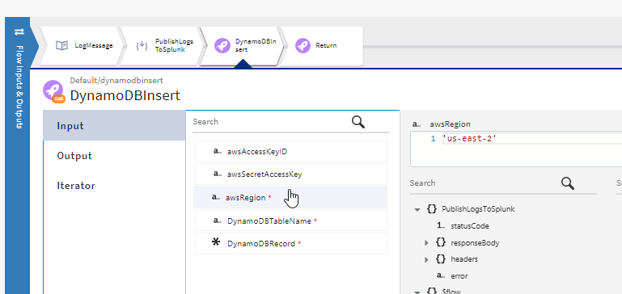

records into dynamodb are inserted as an array of naame value pairs.

string.concat('[{"Name":"firstname", "Value":"',$flow.EventPayload.FirstName,'"},{"Name":"itemcount", "Value":"',$flow.EventPayload.ItemCount,'"},{"Name":"lastname", "Value":"',$flow.EventPayload.LastName,'"},{"Name":"itemnames", "Value":"',$flow.EventPayload.ItemNames,'"},{"Name":"cost", "Value":"',string.tostring($flow.EventPayload.Cost),'"},{"Name":"orderdate", "Value":"',$flow.EventPayload.OrderDate,'"},{"Name":"paymenttype", "Value":"',$flow.EventPayload.PaymentType,'"},{"Name":"bankname", "Value":"',$flow.EventPayload.BankName,'"},{"Name":"id", "Value":"',string.tostring($flow.EventPayload.Id),'"},{"Name":"status", "Value":"',$flow.EventPayload.Status,'"}]')

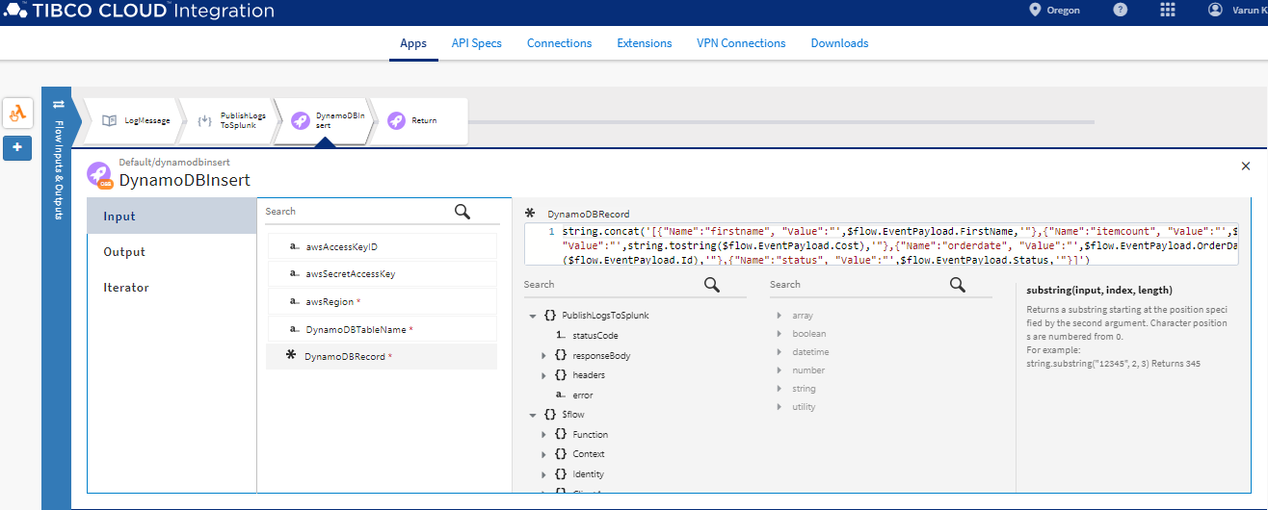

add a log message activity that will cpature if the records is successfuly inserted into the DynamoDB

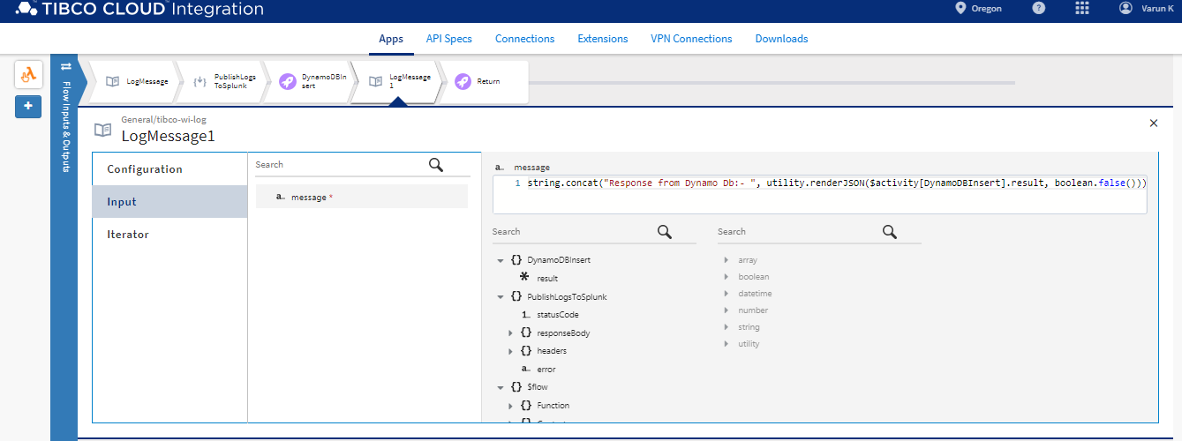

# Assigning A Unique ID To Every Lambda Transaction

In order to track transaction in logs, expicaly in splunk assining a transaction id to every flow riggered.

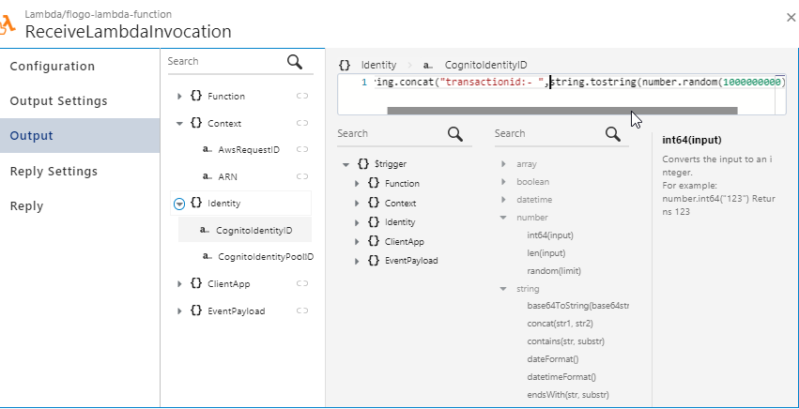

modifying the logs messages accordingly to have the transaction id included.

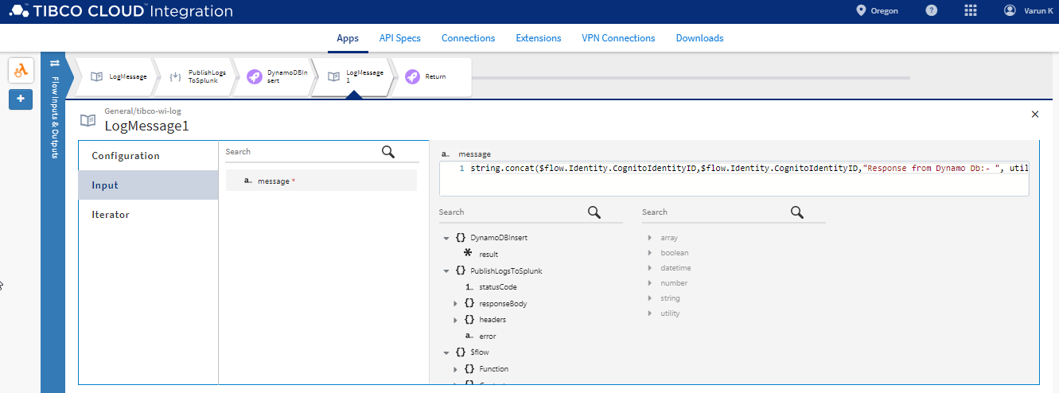

# Error Handling

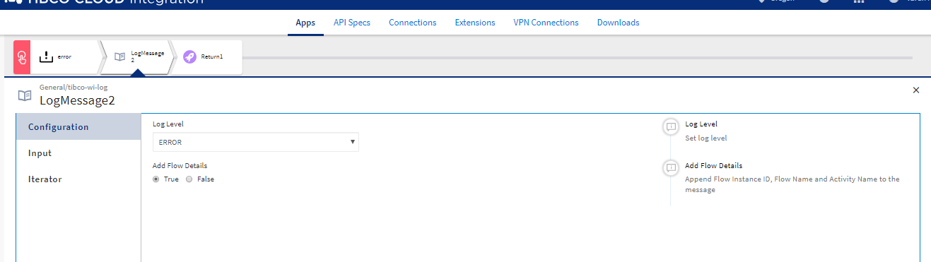

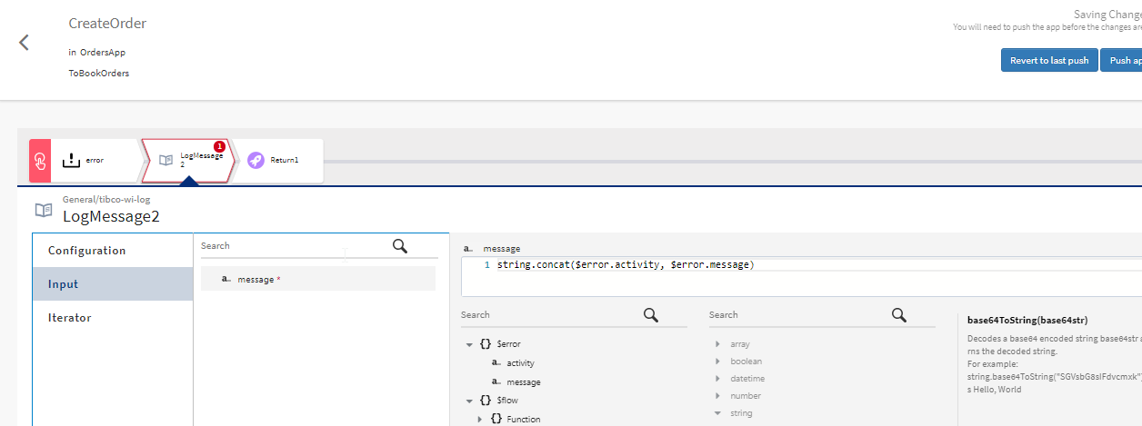

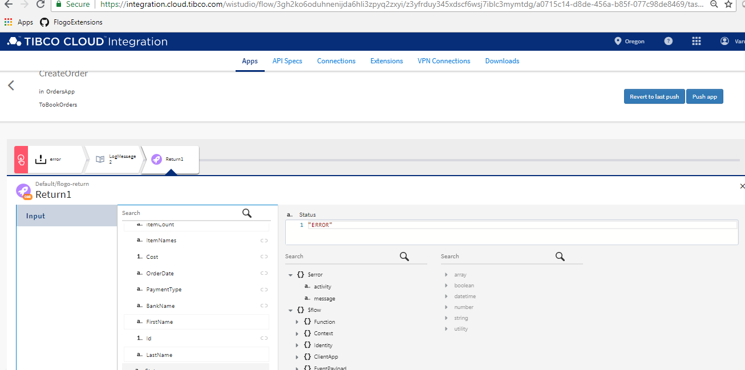

# Testing Record Pesistence To Dynamo DB

Push the code modified for DynamoDB persistence to Lambda

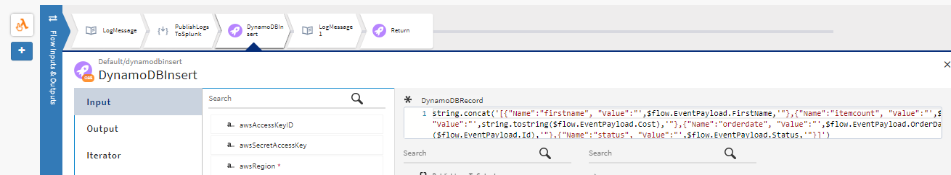

the code is deployed

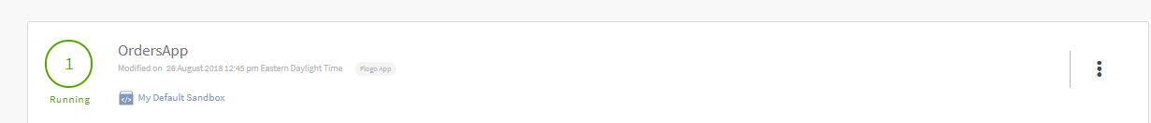

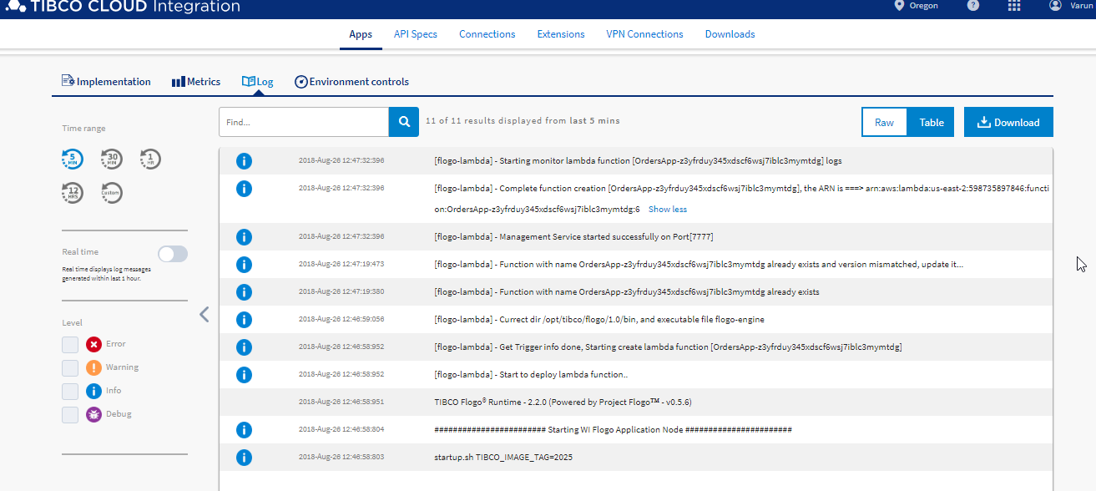

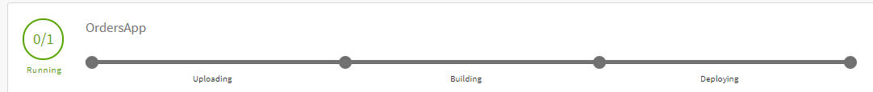

Test the Lambda function, using below payload.

{

"ItemCount": "1",

"ItemNames": "EyeLash",

"Cost": 17,

"OrderDate": "2017-05-27",

"PaymentType": "VISA",

"BankName": "Chase",

"FirstName": "Christhoper",

"Id": "LAN896788",

"LastName": "Lank",

"Status" : "OrderPlaced"

}

checking the logs I see there is an error

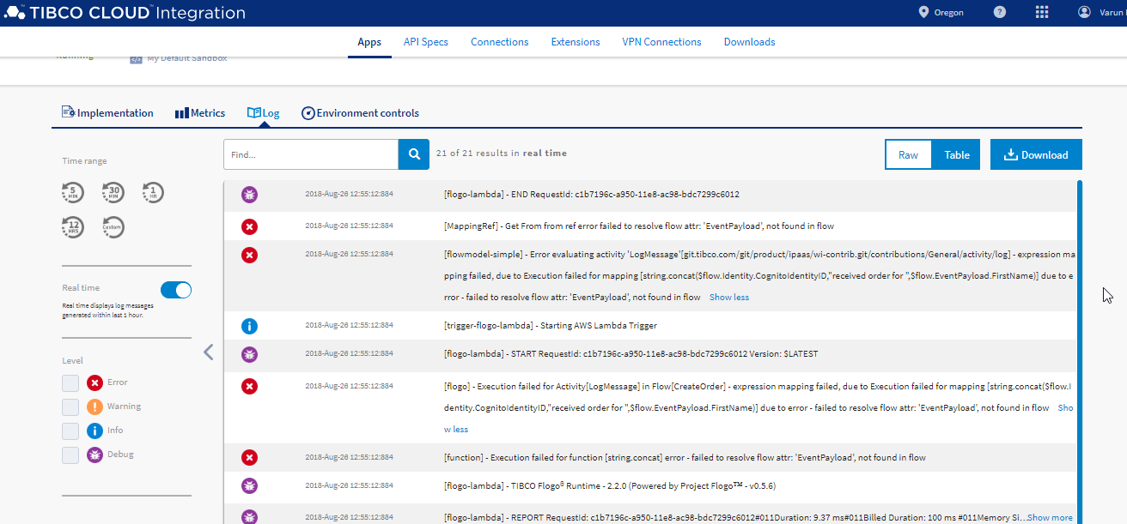

issue was flow details was set to false, change it true

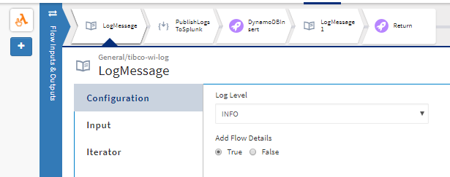

Send the request again. Once the order is successfuly placed you will see that the records has been registered into DynamoDB

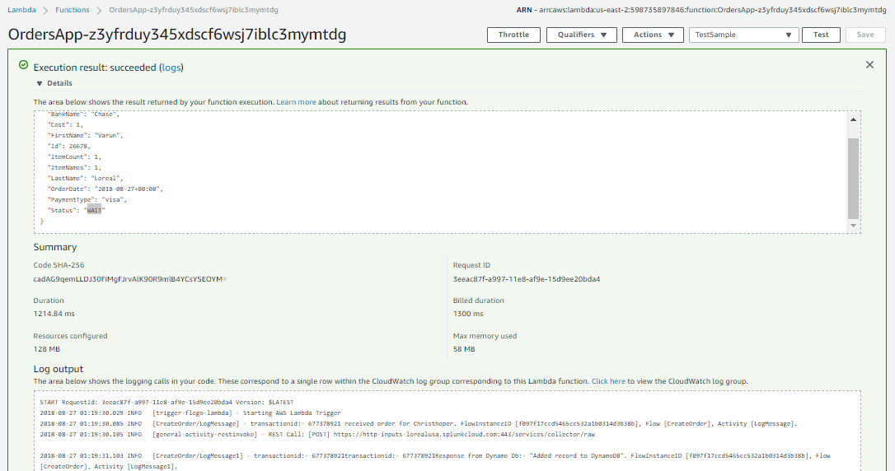

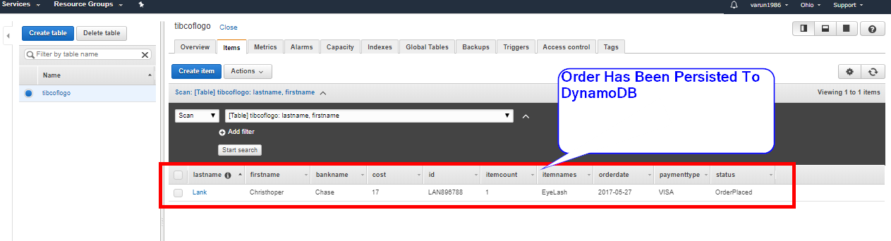

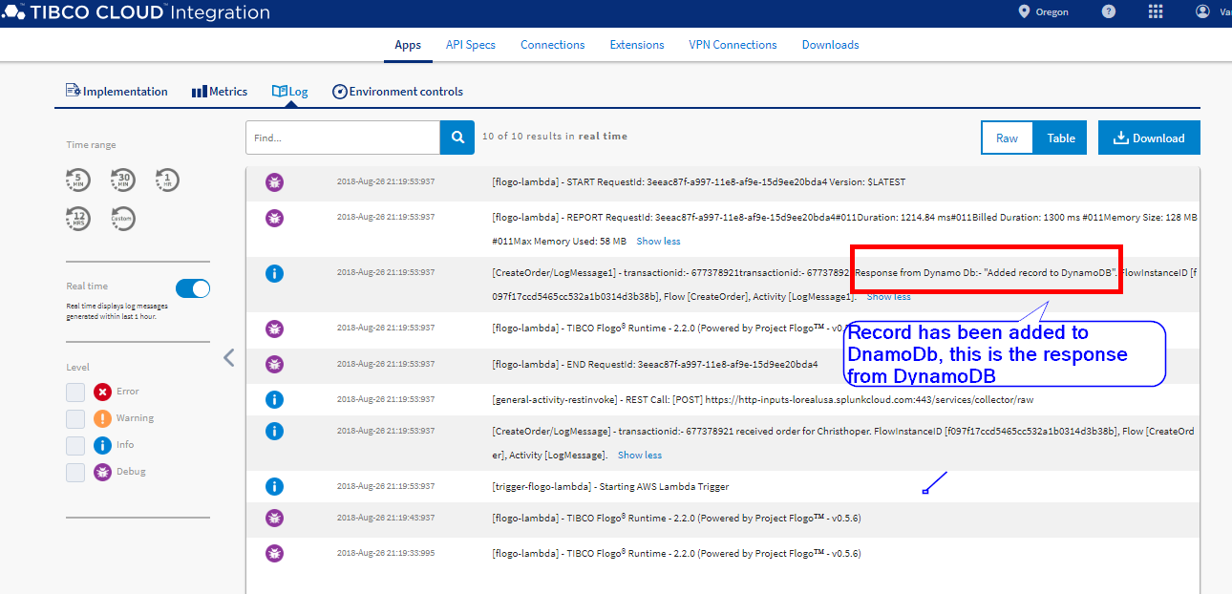

# Facebook App Setup

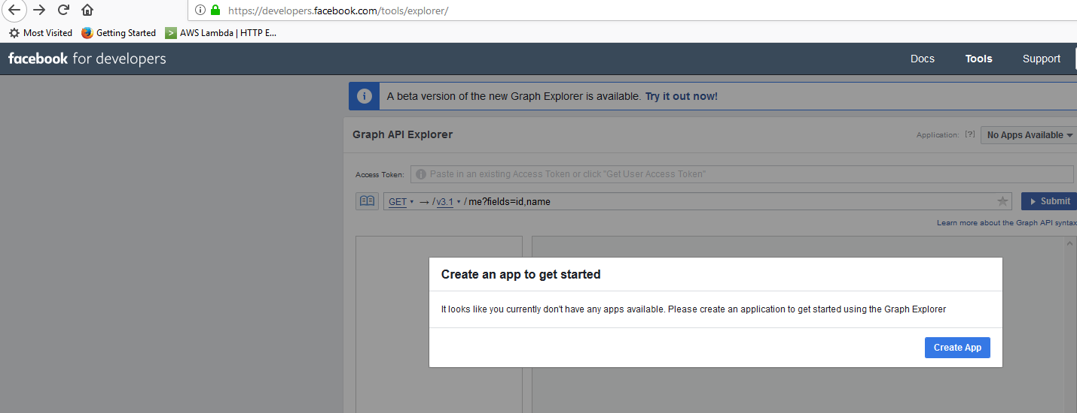

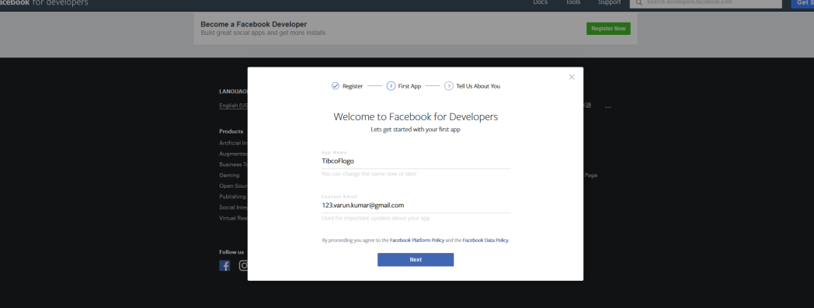

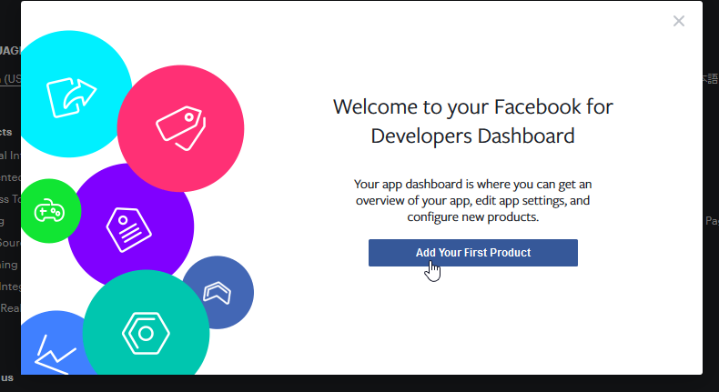

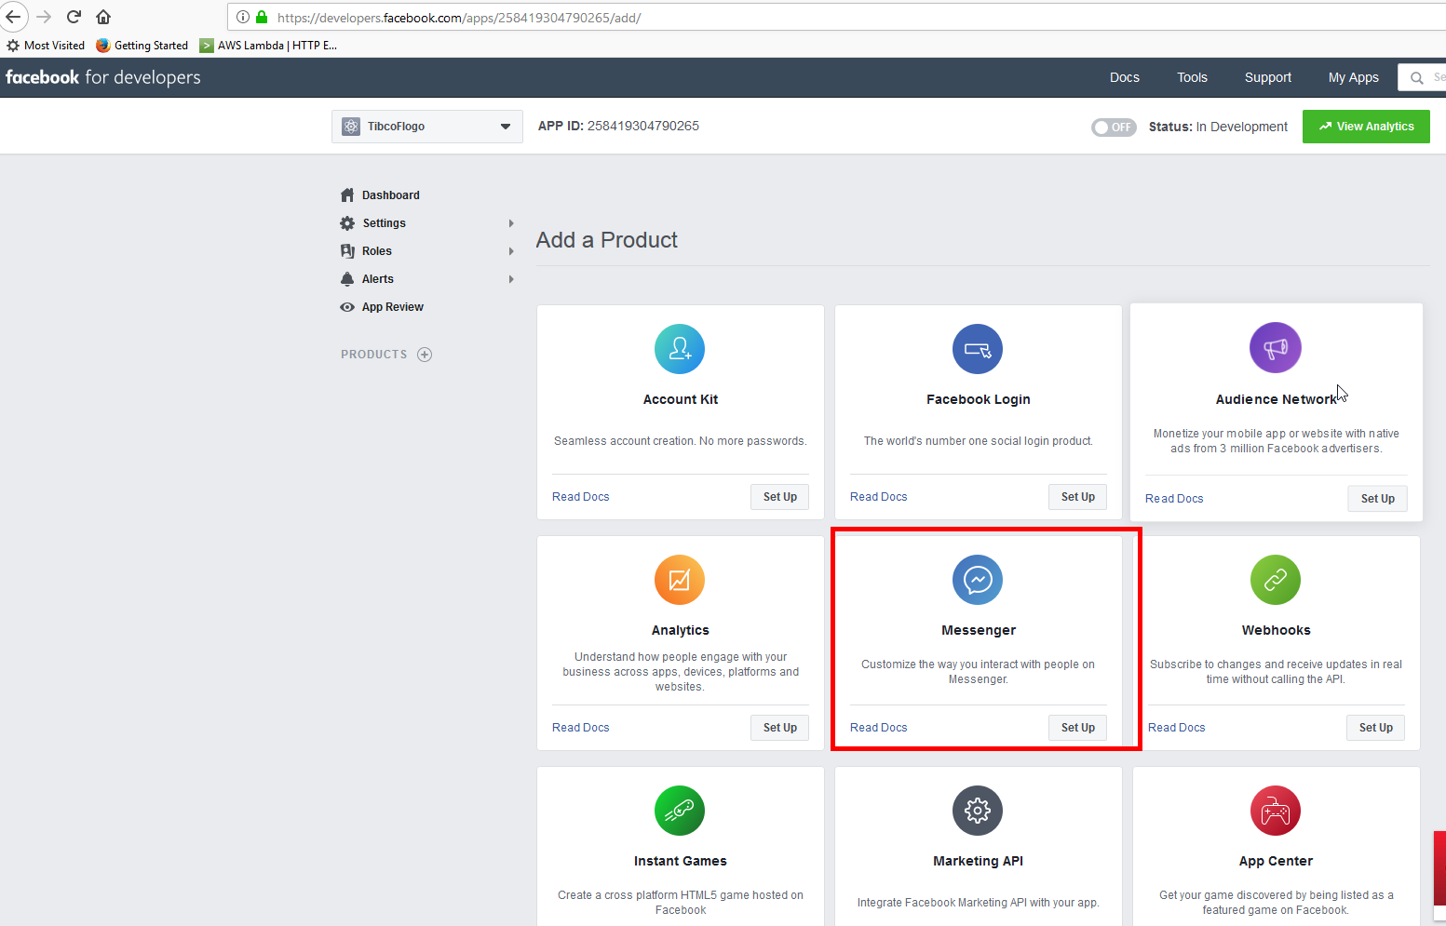

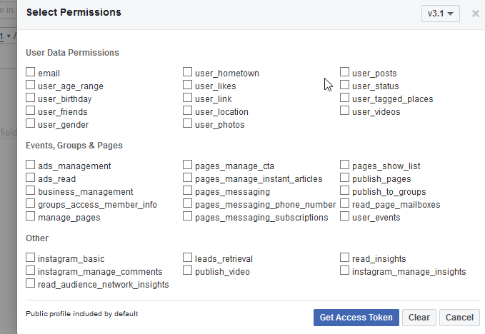

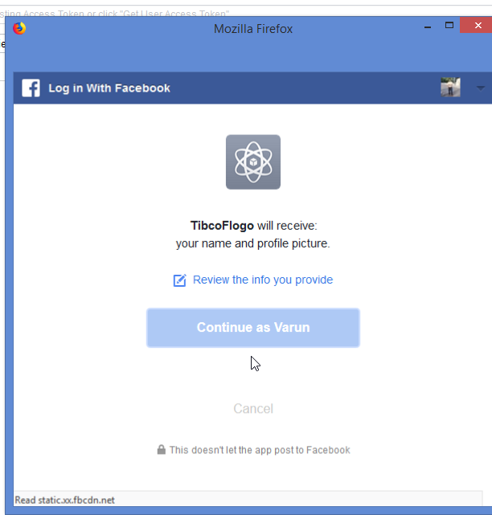

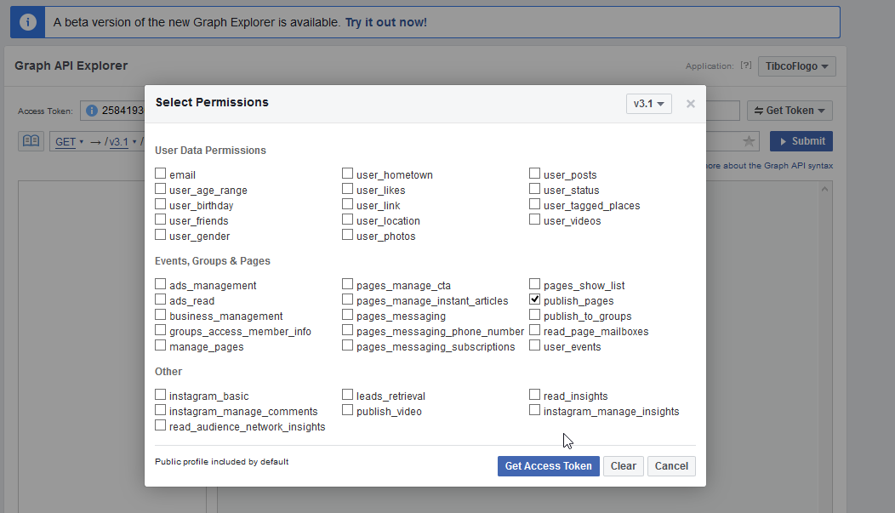

In case of insufficient permissions you will get the error back.

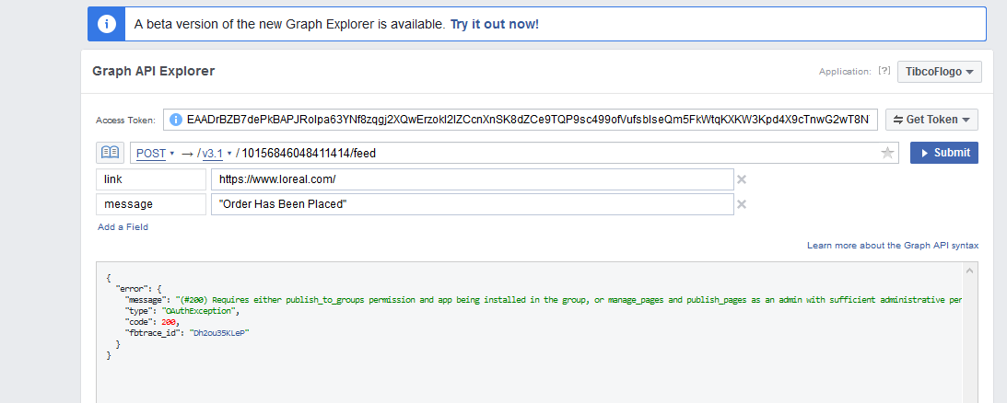

# Flogo Facebook Graph Api

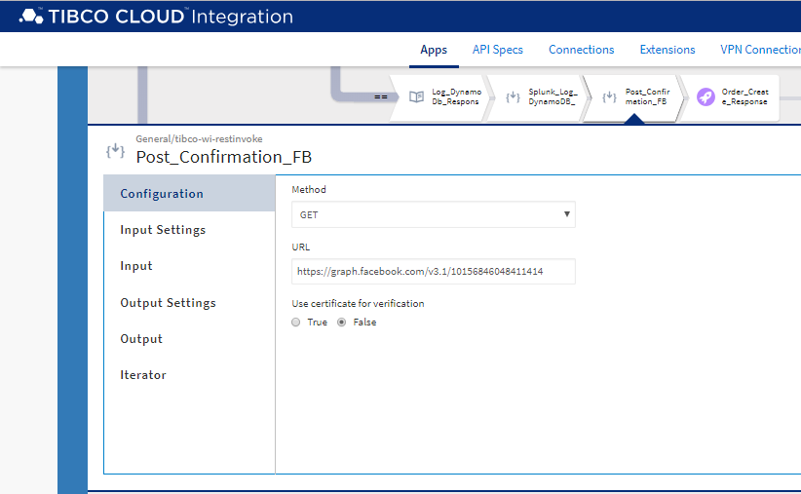

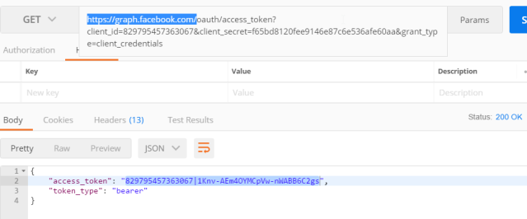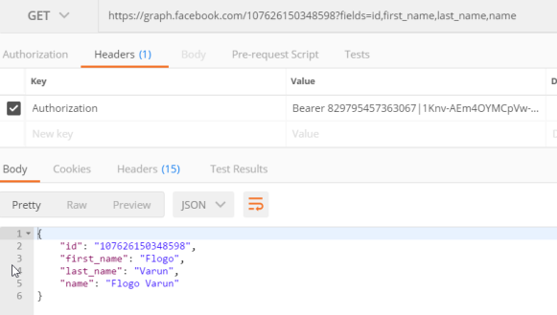

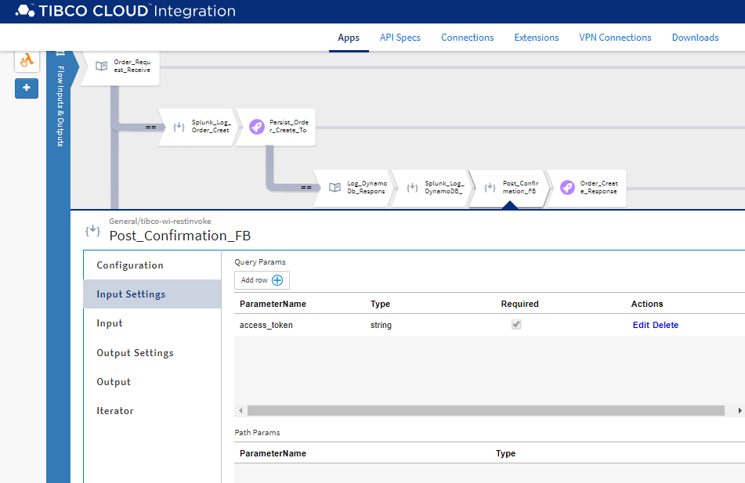

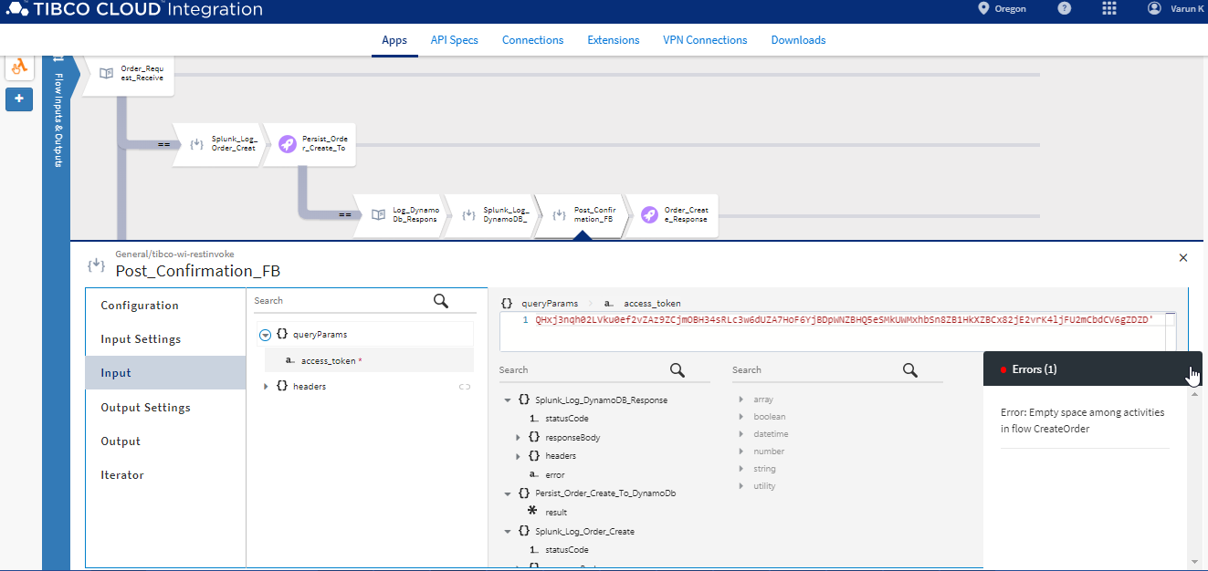

adding F.B response schema

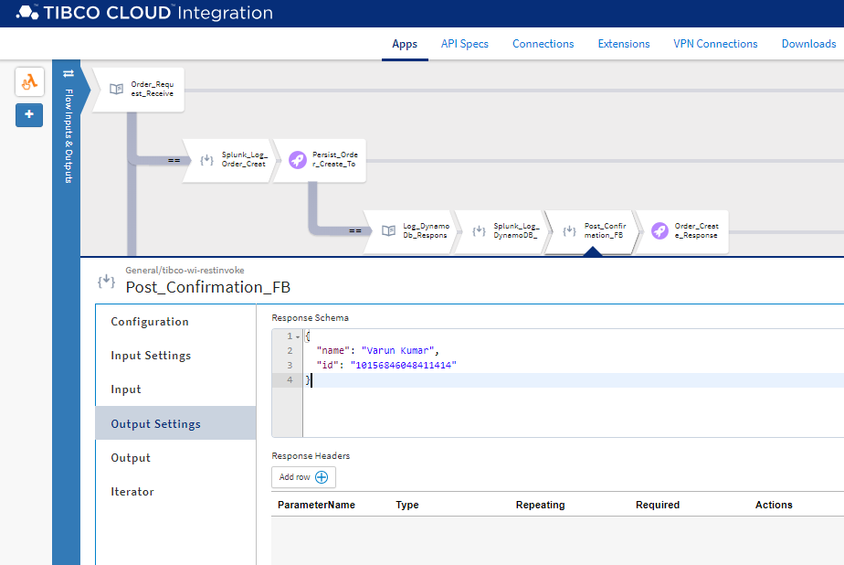

# Creating Multiple Flows

In this scenario we will branch the orders API to have three flow.

1) Will contain a flow that will take the order and persist it to DynamoDB and send a message to the customer's F.B page saying that the order has been placed.

2) The second flow will be for werhouse service to invoke and indicate that the product is available in the wearhouse. The information in DYnamoDB is updated.

3)In the third flow the wearhouse will trigger once the order has been shipped.

# Using Blank Flows

# Iterator

# Configuring AWS IOT Button

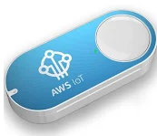 https://docs.aws.amazon.com/iot/latest/developerguide/iot-gs.html

Configure the AWS IOT button using the following steps.

1) Creat a thing for the IOT device.

2) Create a certificate.

3) Associate a policy.

4) assocate all three together.

5) Configure the button.

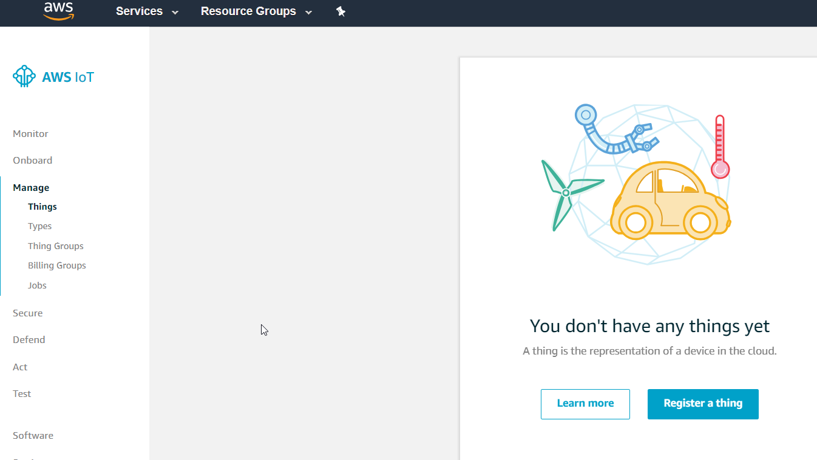

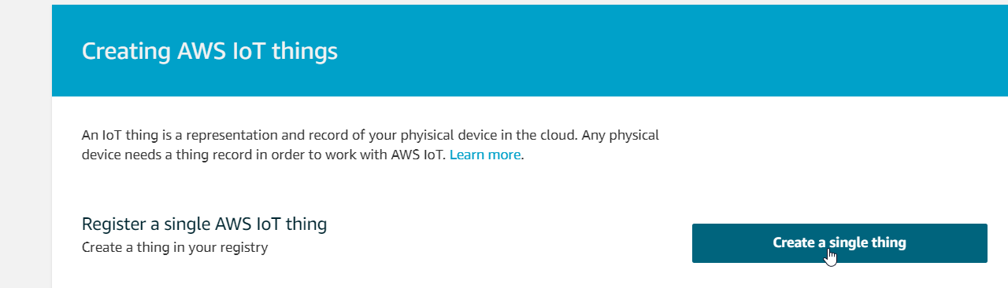

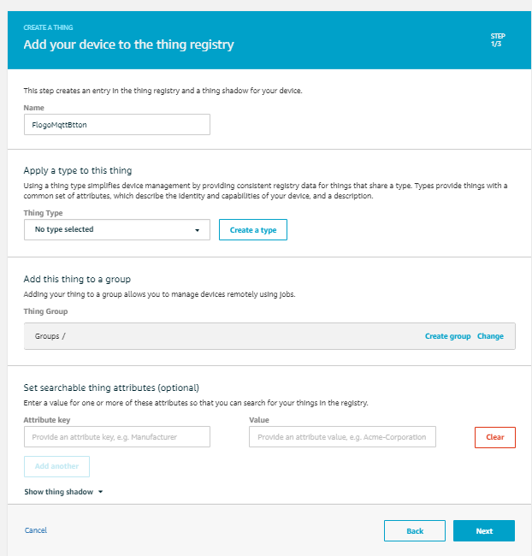 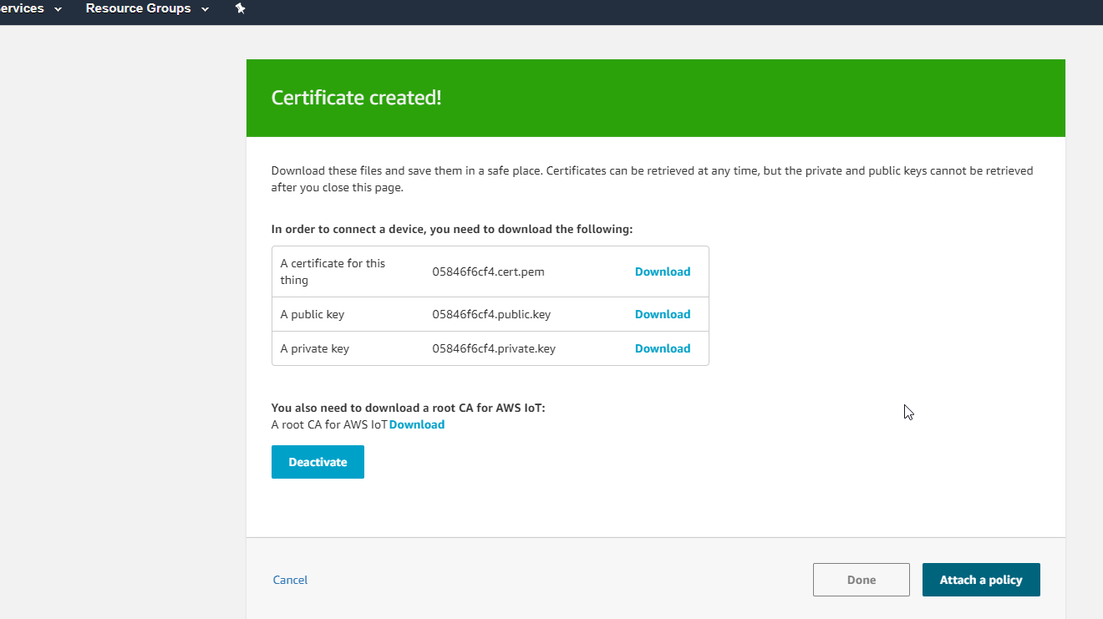

the thing is ready

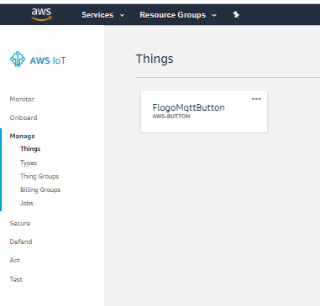

download the certificates



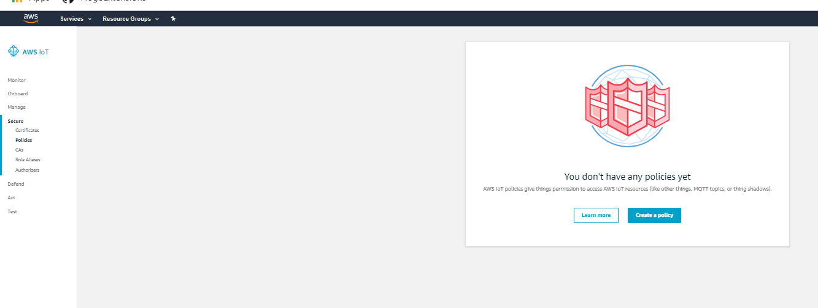

I will use iot:* to let any action.

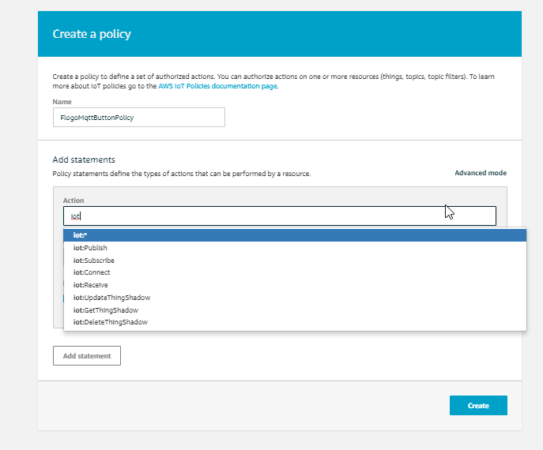

Attach AWS:Iot to device certificate

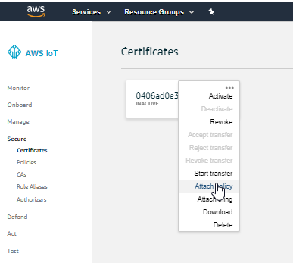 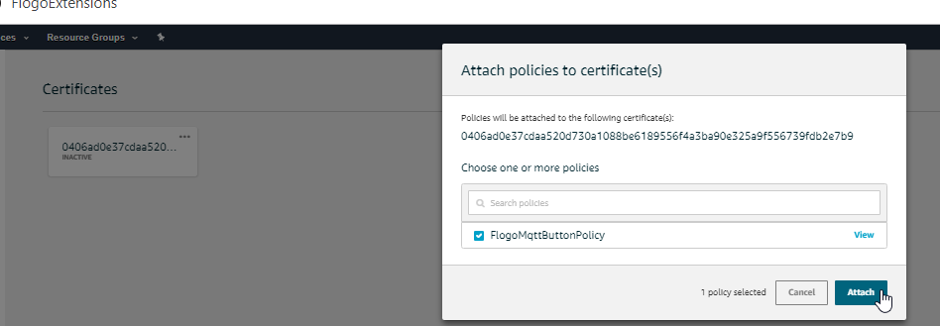

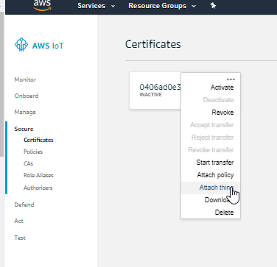

The Thing is configured in AWS IOT. Highlited is called subdomain and used when configuring the button.

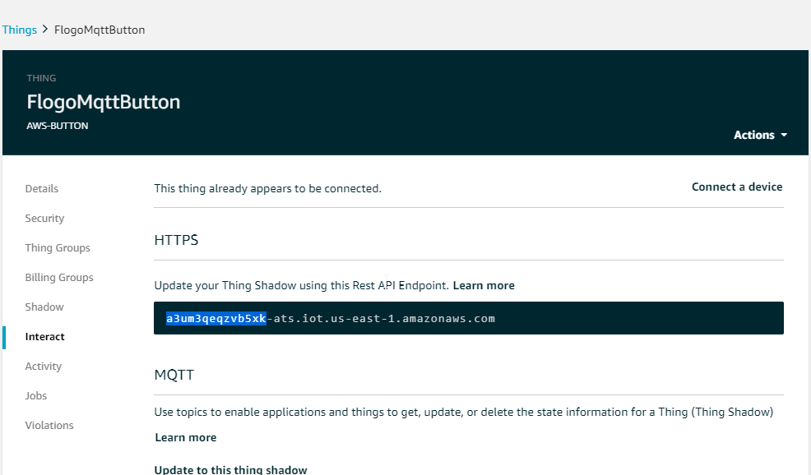

Configure the button

https://docs.aws.amazon.com/iot/latest/developerguide/configure-iot.html

Turn on the AWS iot button by pressing for 15 seconds, till a blue blinking light appears.

Conect to the wifi network as listed

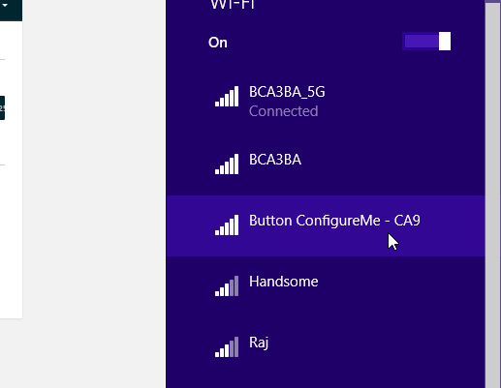connect to this network

Open the url in your browser  <http://192.168.0.1/index.html>

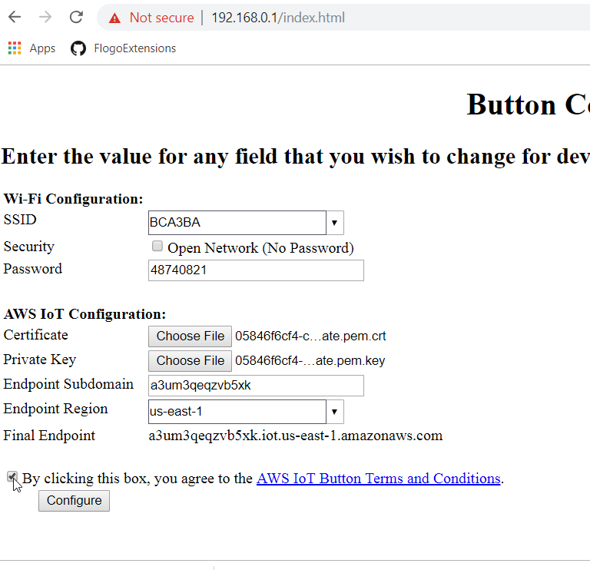

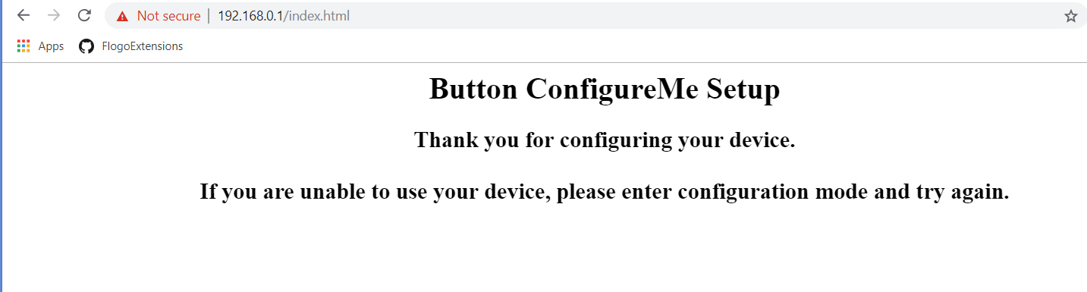

Once configured the button will start blinkig blue.

To test the AWS ITO button is working we can send a test message from the button

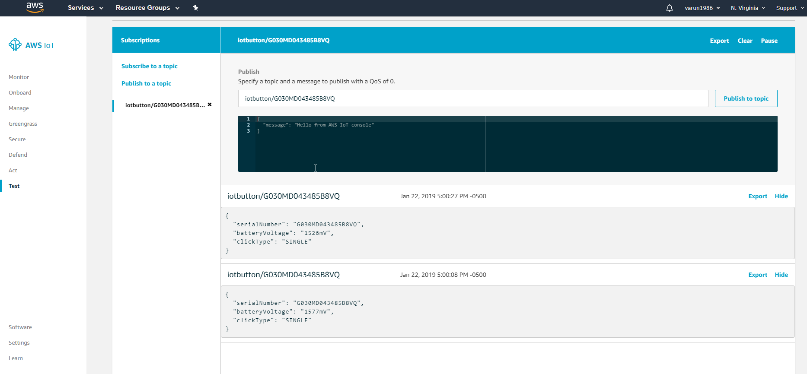

# Testing From A MQTT Client

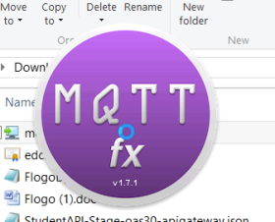

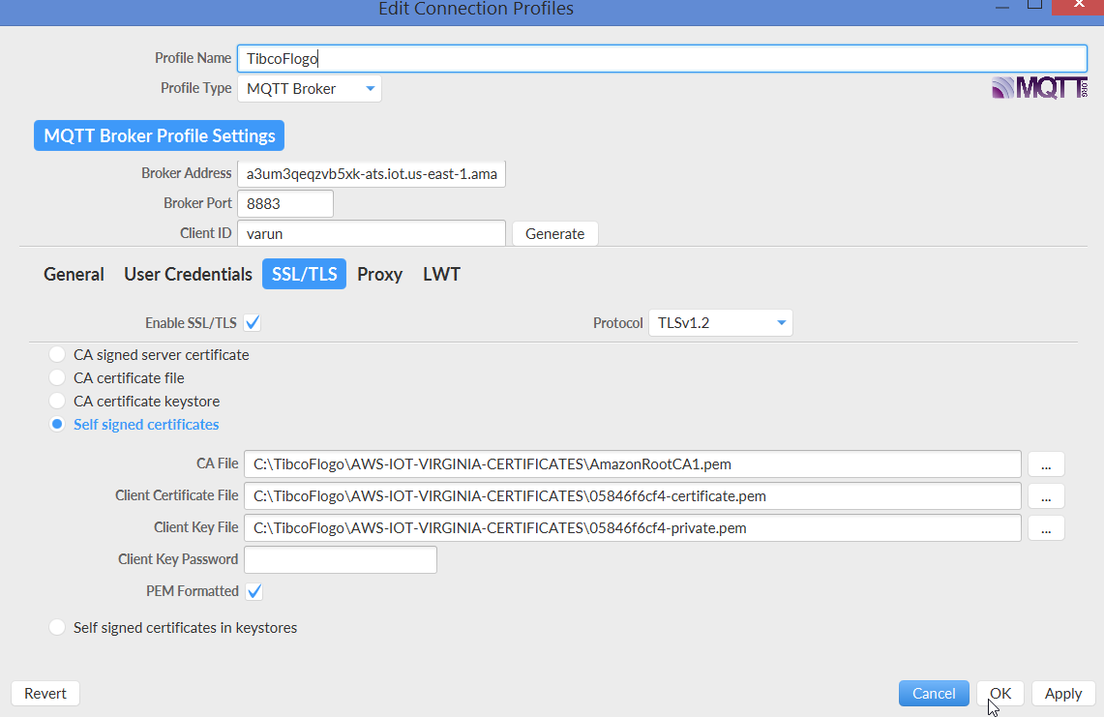

Provide he necessary parameters.

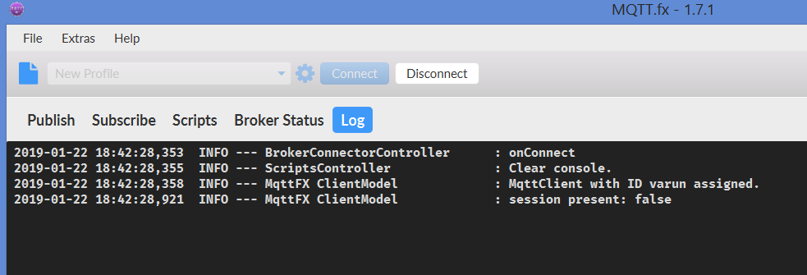

Subscribe to the AWS-IOT-BUTTON topc as sown.

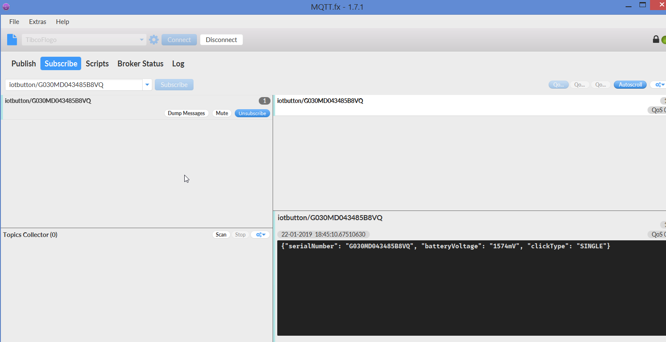

Click the AWS-IOT button and we will see the following message show up.

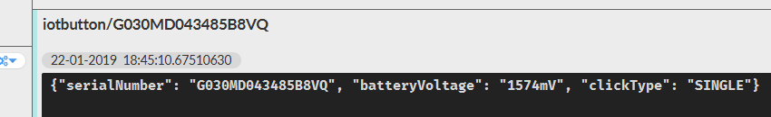

Similarlry we will look at publishing a MQTT message from mqtt.fx and it will be received by MQTT.fx and also in AWS.IOT dashboard.

Published the message here.

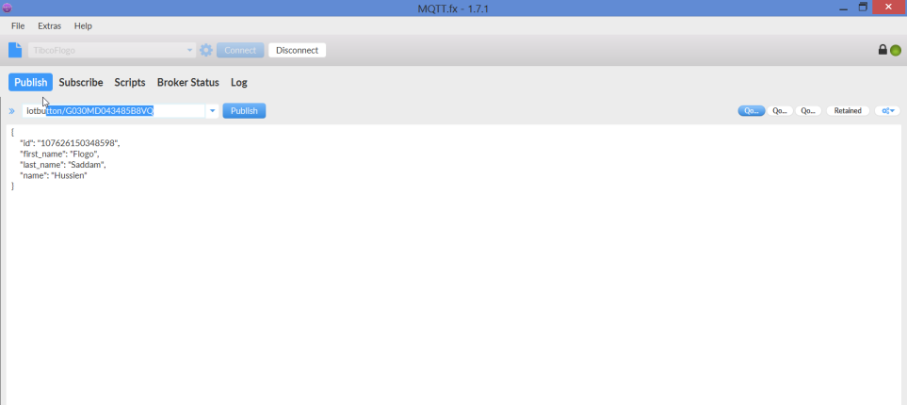

Got the subscription in MQTT.fx

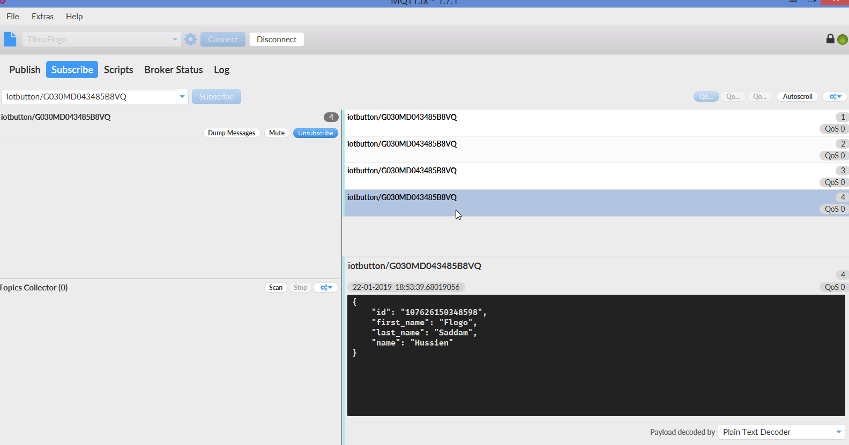

Aslo on the AWS-IOT console.

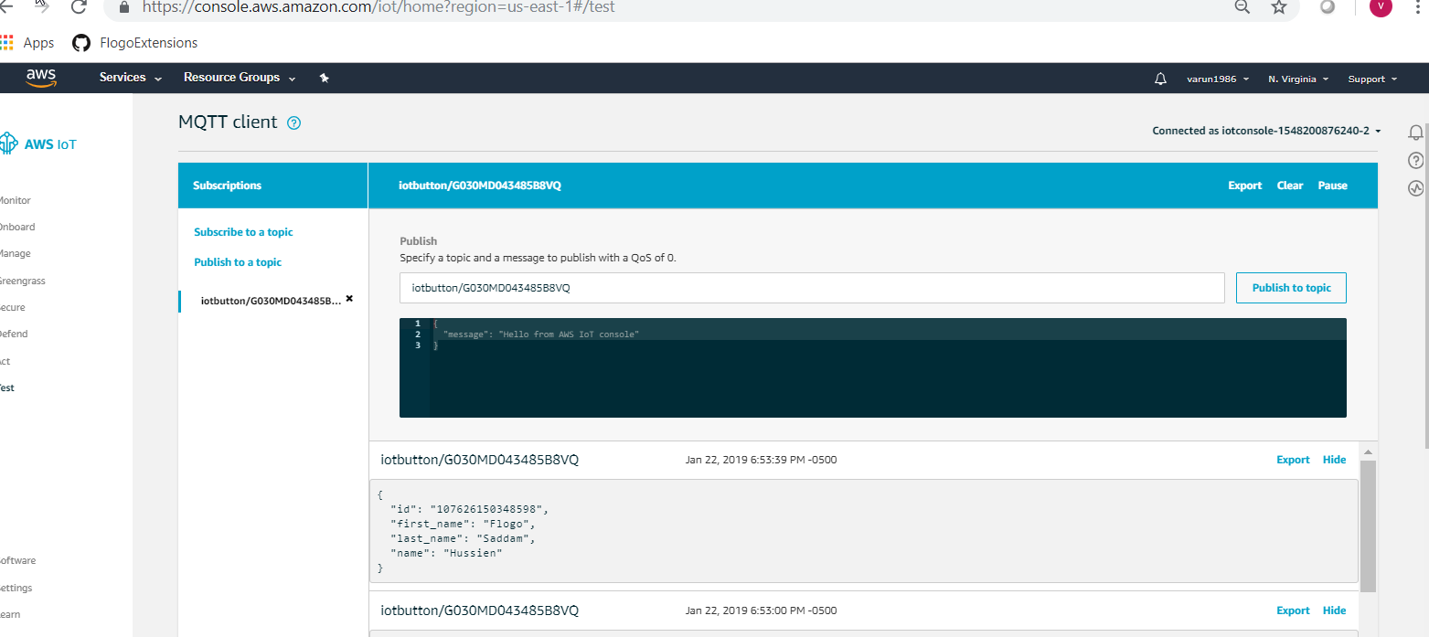

# Most Popular IOT protocols

The first devices connected to the global net appeared in 1982. It was a Coca-Cola vending machine that could control the temperature of the machine and keep track of the number of bottles in it. The term “Internet of Things” is considered to be formulated in 1999 by Kevin Ashton, an RFID technology researcher.

**MQTT** :- Message Queue Telemetry Transport

**DDS**:- Data Distribution Service

**AMQP**:- Advanced Message Queing Protocol

**Bluetooth**:-

**Zigbee** :- is a low-power, low data-rate wireless network used mostly in industrial settings.

**Wifi**

**Cellular**

**LoRaWAN**:- (Long Range Wide Area Network) is a protocol for wide area networks. It is designed to support huge networks (e.g. smart cities) with millions of low-power devices.

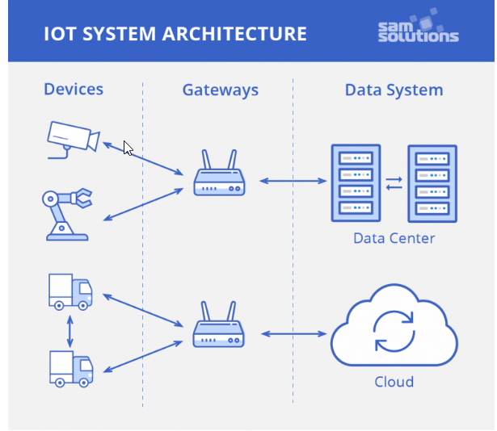

1. **Device to device (D2D)** — direct contact between two smart objects when they share information instantaneously without intermediaries. For example, industrial robots and sensors are connected to one another directly to coordinate their actions and perform the assembly of components more efficiently. This type of connection is not very common yet, because most devices are not able to handle such processes.
2. **Device to gateway** — telecommunications between sensors and gateway nodes. Gateways are more powerful computing devices than sensors. They have two main functions: to consolidate data from sensors and route it to the relevant data system; to analyze data and, if some problems are found, return it back to the device. There are various IoT gateway protocols that may better suit this or that solution depending on the gateway computing capabilities, network capacity and reliability, the frequency of data generation and its quality.
3. **Gateway to data systems** — data transmission from a gateway to the appropriate data system. To determine what protocol to use, you should analyze data traffic (frequency of burstiness and congestion, security requirements and how many parallel connections are needed).
4. **Between data systems** — information transfer within data centers or clouds. Protocols for this type of connection should be easy to deploy and integrate with existing apps, have high availability, capacity and reliable disaster recovery.

# Installing Flogo On AWS Windows2016Server

|  |  |
| --- | --- |
| **Public DNS** | ec2-18-222-209-227.us-east-2.compute.amazonaws.com |
| **User name** | Administrator |
| **Password** | !*9UiHId;j?=dnhYyeSHry5=xO;8Ix!H |

https://www.sam-solutions.com/blog/internet-of-things-iot-protocols-and-connectivity-options-an-overview/

https://docs.aws.amazon.com/iot-1-click/latest/developerguide/iot-1-click-dg.pdf

iotbutton/G030MD043485B8VQ